**UNIFORMS FOR THE CORRECTIONS DEPARTMENT AND THE SHERIFF’S OFFICE**

**REQUIREMENTS**

(1) Swatches of cloth are to be provided when requested.

(2) All prices bid are **FULLY DELIVERED PRICES.**

**MATERIALS**

UNDER THE SPECIFICATIONS ONLY THE BEST COMMERCIAL PRACTICE IS TO PREVAIL AND ONLY MATERIALS AND WORKMANSHIP OF FIRST QUALITY ARE TO BE USED.

**SAMPLES**

One (1) finished sample of each garment or equipment must be available for inspection within ten (10) days of written request from the Ocean County Department of Purchase. **Failure to furnish these samples on time may be cause for rejection of the bid.**

**ADJUSTMENTS AND ALTERATIONS**

The contractor must provide local tailoring facilities for promptly making necessary alterations and adjustments. All complaints will be made within thirty (30) days following delivery. In this regard, upon request by the County, the contractor should provide a list of similar contracts which he has performed within the general Ocean County area.

**DELIVERIES**

The contractor shall make delivery in seven (7) working days after receipt of order (A.R.O.) on all in stock items per this proposal, with the exception of custom made items, which will be delivered in thirty (30) days, A.R.O. This is a requirement of the contract and the contractor warrants by his bid, that he is in a position to supply and deliver all orders as issued by the County, during the contract period for the merchandise set forth within the contract. Unreasonable delays in deliveries will be cause for rescission of the contract.

**SHIPMENTS**

Merchandise must be new and clean and clearly identified with the Purchase Order Number. When names and sizes appear on the purchase order, the vendor must identify the garment with the name and size for efficient sorting and checking. Non-compliance will cause refusal and return of shipment.

**RETURNS**

The successful vendor will be responsible for managing the prompt pick-up of samples and unacceptable items. If pick-up is not effected within ten (10) working days of the pick-up request, the County of Ocean will return said items by common carrier and the vendor will be responsible for the shipping and handling charges.

**UNIFORM FITTING**

Individual uniform measurements are to be taken by the contractor. The contractor **must** provide local tailoring facilities located within Ocean or Atlantic Counties where fittings, returns, exchanges and alterations can be made. Perfect fit must be guaranteed. These measurements are to be taken at a location and date satisfactory to the departments involved. Copies of all measurements taken shall remain on file with the County. Clothing will be inspected as to material, fit and workmanship by a duly authorized representative of the County of Ocean. Failure to comply with this provision may be cause for rescission of the contract.

**CUSTOM UNIFORMS**

**All custom portions of the uniform are to be supplied by the same manufacturer.**

**SAMPLES**

Standard Samples: In all details not specifically described herein, tailoring, styling, materials and construction shall conform to the standard sample on file with the using agency.

Testing of Samples: Samples submitted by bidder will be compared for materials, trim and construction with the standard sample on file with the department. Any sample by a bidder may be subject to test or tests by any testing laboratory that the County may select. All costs in connection with any such test shall be the sole responsibility of the County.

**SECTIONS**

1. Uniforms for the Department of Corrections
2. Uniforms for the Department of Corrections Emergency Response Team (CERT)
3. Uniforms for the Department of Corrections Community Education/Work Crew
4. Uniforms and Equipment for the Ocean County Fire Marshal’s Office
5. Recruit Uniforms and Accessories for the Sheriff’s Office
6. Uniforms, Equipment and Accessories for the Sheriff's Office
7. Tactical Gear for the Sheriff’s Office
8. Tailoring and Alterations, As Needed
9. Discount Rate for Items Not Listed Herein

**SECTION I – UNIFORMS FOR THE DEPARTMENT OF CORRECTIONS**

**ITEM #1 – TROUSERS, CLASS A**

Manufacturer: Fechheimer 48289-T6, or Equal, Navy Blue, 74/25/1 Polyester/Wool/LYCRA®, 12-5-13oz. Serge weave

Style: To be made with two full side straight pockets and two rear pockets, die cut pointed flaps for uniformity of shape and size. Flaps are to have pearl type eyelet style button hole. Density of button hole is 50 stitches per inch with 4 hold 24 ligne plastic button. Front pockets to have approximately 6 ¼" opening and measuring approximately 13" from the top of the opening to the bottom of the pocket. The back pocket opening is approximately 7" deep. One dropped watch pocket which measures approximately 3 ½" wide and 4 ½" deep. One dropped Billy pocket on rear right or left side, depending on officer’s preference, approximately 3 ½" wide and 8" deep. All pockets to be sewn inside out and turned then top stitched for extra strength. All pocket welts are to be interlined with pellon and then top stitched. All trousers are to have 7 belt loops 7/8" wide and 2 ¾" long. All loops are to have double stitching for extra strength. All loops are to be sewn into waistband and dropped to accommodate a 2 ¼" duty belt. All loops are to be sewn in such a manner as not to allow unfinished edges. The base of the loops are to be triple stitched for extra strength.

Pocketing: To be 65% Polyester, 35% Cotton, black

Waistband: Waistband curtain to be black, approximately 3 ¼" wide with 3 rows of snug-tex completely around and 1 5/8" ban-rol to prevent rolling. Top waistband to be single needled top stitched, top and bottom of band for extra strength. Zig zag or chain stitch is not acceptable.

Fly: Zipper to be heavy-duty brass talon #42 style #603 with black color zipper slide. Trouser closure to be crush proof heavy duty hook and eye style with wide French Fly and fly button fastening at base of waistband.

Stripe: Stripe to be 1 ½" wide to be sewn on French Blue material, same as shirt fabric.

Construction: All stress points to be properly bar tacked and closing seams to have a #40 Polyester cord reinforced thread for extra strength. All trousers may have permanently sewn in front creases. Trousers must be properly shaped, the out seams and inseams to be pressed open and flat. All edges will be finished smooth with 18 stitches per inch. There will be no raw edges inside or outside of the trousers. All trousers are to have a care label permanently affixed. All trousers are to have approximately 5" Polyester and Cotton crotch reinforcement sewn in, size to vary depending on trouser size. Trousers to be made straight leg with a minimum 2 ½" turned up cuff. Sewn in crease. All trousers shall be properly sized and delivered clean and well pressed.

Size: Women's: Regular Length: even dress sizes 6-24

Men’s: Regular Length: even waist sizes 28"-54", odd sizes 31"-37"

**SECTION I – UNIFORMS FOR THE DEPARTMENT OF CORRECTIONS (CONT’D)**

**ITEM #2 - LONG SLEEVE SHIRT, CLASS A**

Manufacturer: Elbeco #319N, or Equal

Material: Regulation Police long sleeve shirt with shoulder straps and metal eyelet badge tab. Shirt to be treated with 3M soil release to resist dulling and permanent press. All shirts shall be properly sized and delivered clean and well pressed.

Color: French Blue

Style: All shirts must have a concealed zipper front closure.

Collar: To be stand-up style with permanently fused, shrink proof, 100% Cotton interlining, extra heavy grade, to be ½" wide and approximately 3" long and made of Mylar. Collar stays to be lined with 65% Polyester, 35% Cotton. The collar stay is to go directly to the extreme point of the collar.

Sleeve: To have double reinforced elbows. Reinforcement to be one piece construction and to be double stitched at opening. Reinforcement to be approximately 6 ¾” at widest point and to vary depending on shirt size and is to be sewn into the inseam of the sleeve and into the cuff. Two button cuff to have permanently fused, shrink proof, 100% Cotton interlining, extra heavy grade. Cuffs to be squared off. Rounded cuff is not acceptable.

Pockets: Pockets to be pleated approximately 5 7/8" deep and 5 ¼" wide. Pockets to have eyelets to accept metal buttons with retaining pin. Pocket flaps are to be scalloped style with Velcro on each corner. Flaps are to have fused, shrink proof, 100% Cotton interlining, extra heavy grade. Left pocket only to have 1 ½" pencil division.

Shoulder: Shoulder straps shall be Military style sewn into sleeve seams and cross-stitched. All shoulder straps are to have permanently fused, shrink proof, 100% Cotton interlining. Shoulder strap button to be made removable via ¼" button hole to accept metal button and retaining pin. Shank of button and pin to covered with approximately ⅞" wide and 1 ½" long piece of material the same as the collar band and yoke lining.

Buttons: Buttons to be 25 ligne, New Jersey State Seal on the pocket flaps and shoulder straps, which will fit into corresponding eyelets. Buttons will be silver in color. Eyelets shall be covered inside with a hemmed piece of material to prevent irritation. Balance of buttons to the machine 24 Ligne Melamine.

Emblems: Patches to be supplied by the department and sewn on left sleeve by the vendor.

Size: S–XXXL

**ITEM #3 - COLLAR INSIGNIA**

Silver metal, 1" x ½" clutch back "O.C." "D.C."

**ITEM #4 - 3 SEASON JACKET**

Manufacturer: Blauer #6120, or Equal

Color: Navy

Buttons: All buttons shall be silver NJ State Seal style.

Emblems: Patches to be supplied by the department and sewn on the left sleeve by the vendor. Department patch to be sewn onto left shoulder.

Size: S-XXXL

**SECTION I – UNIFORMS FOR THE DEPARTMENT OF CORRECTIONS (CONT’D)**

**ITEM #5 – FIELD JACKET WITH LINER, M-65 BDU STYLE**

Color: Black

Size: M-4XL

Emblems: Department patch to be sewn on left shoulder. Embroidered name patch to be affixed to right breast.

**ITEM #6 – SOFTSHELL FLEECE JACKET**

Manufacturer: Blauer #4660, or Equal

Features: Lightweight fleece lined, water resistant, zippered shell jacket

Color: Dark Navy

Size: XS – 5XL

**ITEM #7 – PARKA**

Manufacturer: 5.11 3-in-1 Parka #48001, or Equal

Color: Range Red #447

Size: S-3XL

**ITEM #8 - BDU TROUSERS, CLASS C**

Manufacturer: Fechheimer 49300NJFB, or Equal

Color: Navy with French Blue Stripe

Fabric: 6.5 oz. per square yard, twill weave in a 65% Polyester/ 35% Cotton fiber blend with 10-12% filing, stretch that is pre-cured for wrinkle resistance and treated with a soil release finish. Machine washable and dry cleanable Cotton blend.

Customization: Striping – 1.5" French Blue (Color to match shirt fabric)

Standard Size: Men’s: Regular length: even waist sizes 28"-54"; odd sizes 31"-37"

Women’s: Regular length: even dress sizes 6-24

**ITEM #9 - SHORT SLEEVE BDU SHIRT, CLASS C**

Manufacturer: Fechheimer 85R5826 SS, or Equal

Color: Navy with French Blue Stripe

Fabric: 6.5oz. Per square yard 2 x 1 twill weave in a 65% Polyester/ 35% Cotton fiber blend with 10-12% filing stretch that is pre-cured for wrinkle resistance and treated with a soil-release finish. Machine washable and dry cleanable Cotton blend.

Construction: Short Sleeve uniform shirt 5 crease military style with permanent sewn-in creases Top fused convertible sport collar Mitered, pleated pockets with scalloped flaps, pencil opening in left pocket, hook and loop closure Epaulets, Badge eyelets with internal support strap, Extra long shirt tails, Concealed zipper

Embroidery: Vendor will embroider the department’s badge over left breast pocket, embroider "OC" and "DC" on the collars, and embroider the employee's first initial and last name over the right breast pocket on french blue name plate.

Emblems: Patch to be supplied by the department and sewn on left sleeve by the vendor. Battle Flag supplied by the vendor and sewn on right sleeve by vendor.

Size: S-3XL

**SECTION I – UNIFORMS FOR THE DEPARTMENT OF CORRECTIONS (CONT’D)**

**ITEM #10 –LONG SLEEVE POLO SHIRT, CLASS D**

Manufacturer: Elbeco K5138, or Equal

Color: Red

Size: S-3XL

Embroidery: Left side department logo, (approx. 13,318 stitch count, 17 colors, 3.197”W x 3.528”H) –

See Attached Diagram and “Firearms Instructor” below logo (2”H)

**ITEM #11 – BDU PANTS, RIP-STOP**

Manufacturer: Propper #F5252, or Equal

Fabric: 65% polyester, 35% cotton

Color: Khaki

Size: S-XXL

**ITEM #12 – TACTICAL PANTS**

Manufacturer: Elbeco ADV Ripstop #E5702R/E5712LC, or Equal

Description: Men’s Taclite Pro Pants, Poly/Cotton Blend

Color: Khaki

Size: Men: All

Women: 2-16

**ITEM #13 – TACTICAL PANTS**

Manufacturer: 5.11 Style #74273, or Equal

Fabric: 6.2 ounce polyester/cotton Taclite Ripstop

Features: Action waistband, double reinforced seat and knees, triple stitching, hip mounted d ring,

Teflon finish

Color: Khaki

Size: All

**ITEM #14 – TACTICAL POLO, SHORT SLEEVE**

Manufacturer: Elbeco UFX #K5134 and K5135, or Equal

Color: Red, Navy

Embroidery: Left side department logo (approx. 13,318 stitch count, 17 colors, 3.197”W x 3.528”H) – see attached diagram and “Firearms Instructor” below logo (2” H)

Size: All

**ITEM #15 – TACTICAL POLO, LONG SLEEVE**

Manufacturer: Elbeco UFX #K5144 and K5145, or Equal

Color: Red, Navy

Embroidery: Left side department logo (Approx. 13,318 stitch count, 17 colors, 3.197”W x 3.528”H) see attached diagram and “Firearms Instructor” below logo (2” H)

Size: All

**SECTION I – UNIFORMS FOR THE DEPARTMENT OF CORRECTIONS (CONT’D)**

**ITEM #16 - TACTICAL BOOTS**

Manufacturer: 5.11 #12110-120-14R, or Equal

Fabric: nylon and suede

Features: 8” tactical boot, side zip, covert tactical pocket, stay-tied sausage laces

Color: Coyote

Size: 5 - 15

**ITEM #17 - RAINCOAT**

Manufacturer: Newport Harbor #02230, or Equal

Color: Black/Lime

Description: 3M Scotchlite reflective material, reversible, waterproof and windproof

Size: S–3XL

**ITEM #18 – RAIN PANTS, UNISEX**

Manufacturer: Blauer #9134, or Equal

Color: Black

Size: M – 3XL

**ITEM #19 - SENTRY R-801 PERSHING UNIFORM CAP**

Manufacturer: M.J. Cahn #1933-0376, or Equal

Fabric: 100% Polyester P&F Navy Blue Serge.

Features: Visor will be black vinyl 1 ⅝" from the bottom of the cap to the farthest edge of the visor. The sweatband will be a perforated 1 ¼" wide brown bonded leather reeded sweatband machine sewn into the cap. Each cap shall have either 2 silver or 2 gold N.J. State Seal buttons to fasten down the cap strap. Each cap shall have either a silver or gold stretch band on the front of the outerband and a Jaypee NJ-1 overhead strap with either silver or gold hardware to match the stretch band. Sizing will be numerical.

**ITEM #20 - UNIFORM CAP**

Manufacturer: Galls #HW729, or Equal

Fabric: Flexfit V Flex cotton twill ball cap, 98% cotton, 2% spandex

Features: mid-profile fitted cap, permacurv visor, 3 ½” crown with silver under-visor

Color: Red, Black

**ITEM #21 - UNIFORM CAP**

Manufacturer: Taclite #89381, or Equal

Features: ripstop fabric, fully adjustable hook and loop rear strap, bill stitching, integrated crown eyelets

Color: Red, Black

Logo: #1 for OCDOC, FIREARMS INSTRUCTOR to be embroidered on the hat above rear strap

**ITEM #22 - PLASTIC HAT COVER FOR SENTRY R-801 PERSHING UNIFORM CAP**

Color: Clear

Feature: Elastic bottom for secure fit over hat.

**SECTION I – UNIFORMS FOR THE DEPARTMENT OF CORRECTIONS (CONT’D)**

**ITEM #23 – LONG SLEEVE KHAKI TWILL SHIRT**

Manufacturer: VF-ST5CK, or Equal

Fabric: 65/35 Polyester/Cotton twill

Size: S - XL

Features: Shirt must have sewn in military creases, 3 on back and 2 on front.

Emblems: The Ocean County Corrections Department patch must be sewn on right sleeve by the vendor and Academy patch sewn on left sleeve or breast pocket (based on Academy specifications).

Tailoring: Shirts must be tapered to fit the individual.

**ITEM #24 – KHAKI TWILL TROUSERS**

Manufacturer: VF-PT62KH, or Equal

Fabric: Polyester/Cotton twill

Size: 30” – 48” waist

Features: Trousers must have sewn-in crease on the front of each leg.

Tailoring: Trousers must be fitted to the individual.

**ITEM #25 – WATCH CAP**

Manufacturer: Alan Sloan #6610, or Equal

Fabric: Heavy Weight Acrylic Knit

Color: Black

**ITEM #26A & 26B – CLIP-ON NECK TIE**

1. Manufacturer: Samuel Broome, or Equal

Size/Item #: 18" - #90010

20" - #90043

22" - #90063

Color: Navy Blue (Post Graduation), Black (Academy)

1. Manufacturer: Samuel Broome, or Equal

Size/Item #: 18" - #90010

20" - #90043

22" - #90063

Color: Black (Academy)

**ITEM #27 - NAME TAG**

Silver, with black lettering to read: First Initial, Last Name

**ITEM #28 – TIE BAR**

Silver, with black lettering to read: "Ocean (NJ STATE SEAL) County"

**ITEM #29 – TRAINING BELT**

Manufacturer: Rothco Reflective Physical Training Belt #60390, or Equal

Fabric: Yellow PVC material with polyester lining

Features: Fully adjustable with slide adjustment buckle, side-release buckle closure

Size: 45” x 2” wide

**SECTION I – UNIFORMS FOR THE DEPARTMENT OF CORRECTIONS (CONT’D)**

**ITEM #30 – LEATHER BELT**

Manufacturer: Garrison #E04, or Equal

Fabric: Full grain leather with a porvair finish to prevent scratches and abrasion, which is no less than 1/8" thick.

Buckle: Nickel color, square

Size: Finish width 1 ½", smooth edges

Color: Black

**ITEM #31 – TACTICAL BELT**

Manufacturer: 5.11 Tactical Operator

Features: 1 ¾” Wide tactical belt, stainless steel buckle, tested for strength up to 5,100 pounds, fade and rip resistant, ultra-strong nylon mesh

Color: Black

Size: All

**ITEM #32 –ELECTRONIC HEARING PROTECTOR HEADPHONES**

Manufacturer: 3M Peltor Sport Tactical 500, TAC500-OTH, or Equal

Features: Electronic hearing protector shall be equipped with Bluetooth Wireless Technology, dynamic suppression time, clear voice tracking, recessed microphones, foldable and adjustable.

**ITEM #33 –ALTA BAT BUCKLE**

Manufacturer: Style 59538, or Equal

Features: Parachute grade metal buckle with sliding tension bar, convertible to a tie down or carry strap, triangle D-ring

Fabric: Bonded nylon thread

Color: Black

Size: S – 4XL

**ITEM #34A & 34B – CREW NECK T-SHIRT**

a.) Manufacturer: Hanes #5180, or Equal

Color: White, Gray, Navy

Fabric: 100% Cotton

b.) Manufacturer: Hanes #5180, or Equal

Color: White, Gray, Navy

Fabric: 100% Cotton

Customization: Recruits last name to be screen printed in 2" block letters on front and back in black or yellow.

**ITEM #35A & 35B – GYM SHORTS**

1. Manufacturer: Augusta #990, or Equal

Color: White, Gray, Navy

Fabric: 100% Cotton with Elastic Waist

1. Manufacturer: Augusta #990, or Equal

Color: White, Gray, Navy

Fabric: 100% Cotton with Elastic Waist

Customization: Recruits last name to be screen printed in 2" block letters on back in black or yellow.

**ITEM #36 – BASEBALL CAP**

Manufacturer: Flexfit Pro-Style Wool #6677, or Equal

Features: Pro-style, high profile hape**,** hard buckram, Silver undervisor, 8 rows of stitching on visor

Color: Black

Size: 6 7/8” – 7 3/8”

**SECTION I – UNIFORMS FOR THE DEPARTMENT OF CORRECTIONS (CONT’D)**

**ITEM #37A & 37B – LONG SLEEVE CREW NECK SWEAT SHIRT**

1. Manufacturer: Jerzees #562M, or Equal

Fabric: 50/50 Polyester/Cotton blend

Color: Navy, Gray

Size: S-XXXL

1. Manufacturer: Jerzees #562M, or Equal

Fabric: 50/50 Polyester/Cotton blend

Color: Navy, Gray

Size: S-XXXL

Customization: Recruits last name to be screen printed in 2" block letters on front and back in black or yellow.

**ITEM #38A & 38B – PULL-OVER SWEAT SHIRT, HOODED**

1. Manufacturer: Jerzees #996MR, or Equal

Fabric: 50 % Cotton/50% Polyester

Color: Medium Gray, Navy

1. Manufacturer: Jerzees #996MR, or Equal

Fabric: 50 % Cotton/50% Polyester

Color: Medium Gray, Navy

Customization: Recruits last name to be screen printed in 2” block letters on back in black or yellow.

**ITEM #39A & 39B - SWEAT PANTS**

1. Manufacturer: Jerzees #973M, or Equal

Fabric: 50/50 Polyester/Cotton blend

Features: Drawstring Waist

Color: Navy, Gray

Size: S-XXXL

1. Manufacturer: Jerzees #973M, or Equal

Fabric: 50/50 Polyester/Cotton blend

Features: Drawstring Waist

Color: Navy, Gray

Size: S-XXXL

Customization: Recruits last name to be screen printed in 2" block letters on back in black or yellow.

**ITEM #40 – CARGO BAG**

Manufacturer: Rothco Canvas Parachute Bag #BG687, or Equal

Fabric: Cotton, Canvas

Features: D-ring located at each end next to zipper under flap, reinforced web handles

Color: Black, Green (preferred)

**SECTION II – UNIFORMS FOR THE DEPARTMENT OF CORRECTIONS EMERGENCY RESPONSE TEAM (CERT)**

**ITEM #41 – FIELD JACKET WITH LINER**

Manufacturer: Tru-Spec Style #2440M-65 Field Jacket with liner, or Equal

Features: Pull out hood that packs into zippered compartment on collar, heavy brass zipper with

pull tab covered by storm flap with snap button closure

Color: Black

Size: All

**ITEM #42 – STRETCH FIT CAP**

Manufacturer: Under Armour, Friend or Foe stretch fit cap

Fabric: 100% polyester, stretch fit, with subdued American flag logo on left side

Size: Stretch fit

Color: Black

**ITEM #43 – TACTICAL POLO, LONG SLEEVE**

Manufacturer: Elbeco #K5148, UFX Tactical Long Sleeve Polo, or Equal

Color: Gray

Size: All

Logo: CERT logo on upper left chest; 3 ½” high by 2 ½” wide or closest to scale, see attached diagram

**ITEM #44 – TACTICAL POLO, SHORT SLEEVE**

Manufacturer: Elbeco #K5138, UFX Tactical, or Equal

Size: All

Color: Gray

Logo: CERT logo on upper left chest; 3 ½” high by 2 ½” wide or closest to scale, see attached diagram

**ITEM #45 – TACTICAL POLO, LONG SLEEVE**

Manufacturer: 5.11 Rapid Assault Shirt

Features: Dual fabric construction, large storage pockets at each shoulder, ¼ zip front

Color: Black

Size: All

Embroidery: CERT logo on upper left chest; 3 ½” high by 2 ½” wide or closest to scale, see attached diagram

**ITEM #46 – TACTICAL OUTER CARRIER**

Manufacturer: GH Armor #BY559, Tactical Outer Carrier, or Equal

Features: Nylon outer material, moisture wicking inner lining for heat and moisture, fixed pockets, concealable ballistic panels, internal 5x8 and 8x10 trauma plate pockets, rear pockets for dual handcuffs, hidden chest pocket with zipper closure, fully adjustable side and shoulder closures with durable high profile Velcro brand

Color: Black

Size: All

**SECTION II – UNIFORMS FOR THE DEPARTMENT OF CORRECTIONS EMERGENCY RESPONSE TEAM (CERT) (CONT’D)**

**ITEM #47 – TACTICAL PANTS**

Manufacturer: Tru-Spec 24-7 Ripstop pants, or Equal

Features: 6.5 oz, 65% polyester, 35% cotton ripstop fabric, Teflon coated comfort fit slider waistband

Color: Black

Size: All

**ITEM #48 – TACTICAL BOOTS**

Manufacturer: Rocky AlphaForce side zipper, waterproof duty boot, or Equal

Features: Lightweight 1000 denier nylon, 8 inches in height, oil and slip resistant, non-marking Rigi Trac molded Eva/rubber outsole

Color: Black

Size: All

**ITEM #49 – TACTICAL CARRIER**

Manufacturer: GH Armor, or Equal

Features: Tactical outer carrier (TOC), durable 500 denier cordura nylon outer material, external tactical carrier with fixed pockets, internal 5” x 8” and 8” x 10” front trauma plate pockets, front pockets include 6” x 6” utility for pen/flashlight, triple mag and universal radio, hidden chest pocket with zipper closure, fully adjustable side and shoulder closures with durable high profile velcro brand.

Color: Black

Size: All

**ITEM #50 – TACTICAL VEST**

Manufacturer: GH Armor ProX Series, or Equal

Features: Body armor package level IIIA, NIJ standard- 0101.06 certified, exclusive protect internal ballistic desiccant for moisture management and durability of performance. Second carrier included with proX package

Color: Black

Size: All

**ITEM #51 - RAINCOAT**

Manufacturer: LawPro 48” deluxe reversible raincoat with hood, #’s M703r/M7030/M703Y/M7

Features: Waterproof nylon poly vinyl, snap front closure with storm flap

Color: Black/yellow

Size: All

**ITEM #52 – WATCH CAP**

Manufacturer: 5.11 #89250, or Equal

Fabric: High performance polyester fleece

Color: Black (019)

Size: All

**ITEM #53 - GLOVES**

Manufacturer: 5.11 Tactical Hard Knuckle Gloves, or Equal

Features: Thermoplastic knuckle plates, tactical touch precision fingertips, seamless goatskin palm

Color: Black

Size: All

**SECTION II – UNIFORMS FOR THE DEPARTMENT OF CORRECTIONS EMERGENCY RESPONSE TEAM (CERT) (CONT’D)**

**ITEM #54 - BALACLAVA**

Manufacturer: Blackhawk heavyweight balaclava, #333002BK, or Equal

Features: Constructed of 7.4 oz. Nomex

Color: Black

**ITEM #55 – FLIGHT SUIT**

Manufacturer: Tru-Spec 27/P Flight Suit, or Equal

Fabric: 65% polyester / 35% cotton twill

Features: 2-way front zipper

Color: Black

Size: All

**ITEM #56 – KNEE PADS**

Manufacturer: Blackhawk #808300, or Equal

Features: Advanced tactical knee pads V.2, 600 denier nylon shell, hook & loop elastic straps

Color: Black

**ITEM #57 – FOREARM PADS**

Manufacturer: Damascus FP10 Imperial Eva foam forearm, or Equal

Features: Hard shell plastic inserts, two adjustable straps material, forearm diameter: 8-13 inches

Size: Universal

Color: Black

**ITEM #58 – ELBOW PADS**

Manufacturer: Blackhawk advanced tactical elbow pads V.2, #802600BK, or Equal

Features: 600 denier nylon shell, non-slip, flexible, molded polyurethane cap, hook and loop elastic straps

Color: Black

Size: All

**ITEM #59 – SHIN GUARDS**

Manufacturer: Galls #TE222, or Equal

Features: Double knee, extended side protection, additional strap at base of leg/ankle

Size: All

Color: Black

**ITEM #60 – BALLISTIC HELMET**

Manufacturer: PASGT Ballistic helmet, NIJ 0106.01 type IIIA protection, four-point adjustable retention system

Size: All

Color: Black

**ITEM #61 - TACTICAL HOLSTER**

Manufacturer: SafariLand #6004 SLS, Glock 21, or Equal

Features: SLS rotating hood system for a smoother, single motion draw, hood guard, suede lined, leg straps featuring silicone strips, left and right sides

Color: Black

**SECTION II – UNIFORMS FOR THE DEPARTMENT OF CORRECTIONS EMERGENCY RESPONSE TEAM (CERT) (CONT’D)**

**ITEM #62 - AEROSOL HOLDER**

Manufacturer: Tru-Spec #9030, MK III Mace holder, or Equal

Features: 1680D Ballistic Pack Cloth, full flap with hidden single snap closure on each pocket to secure canisters, for use with 2" duty belts, 6" X 2 3/4"

**ITEM #63 - HANDCUFF CASE**

Manufacturer: Tru-Spec #9035, or Equal

Features: Single nylon handcuff case, 1680D ballistic pack cloth, full flap with hidden single snap closure on each pocket, for use with 2" duty belts, 5 1/2" x 4"

**ITEM #64 - DUTY BELT**

Manufacturer: Sierra Bravo Duty Belt Kit, or Equal

Features: 1,680D denier nylon, MOLLE/5.11 and Slickstick compatible, dual belt configuration, inner belt width 1.63"

Color: Black

Size: All

**ITEM #65 – BELT KEEPERS**

Manufacturer: Sierra Bravo Keepers 2.25”, or Equal (Replacement belt keepers for the 2.25 Sierra Bravo duty belt plus kit)

Color: Black

Size: All

**SECTION III – UNIFORMS FOR THE DEPARTMENT OF CORRECTIONS COMMUNITY EDUCATION/WORK CREW**

**ITEM #66 - FLEECE JACKET**

Manufacturer: Blauer #4660, or Equal

Features: Softshell fleece jacket, lightweight fleece-lined, water resistant finish

Color: Dark Navy

Size: All

**ITEM #67 - PARKA**

Manufacturer 5.11, 3 in 1 parka, #48001, or Equal

Color: Dark Navy

Size: All

**ITEM #68 - TACTICAL BOOTS, MEN AND WOMEN**

Manufacturer: 5.11 ATAC 6" side zip boot, or Equal

Features: Cushioned Ortholite insole, non-metallic shank, oil and slip resistant outsole, semi-rigid heel and toe reinforcement, full grain leather, moisture-wicking lining

Color: Black

Size: Female 5-10

Male 4 - 15

**ITEM #69 - TACTICAL BOOTS**

Manufacturer: Rocky 10" Paratrooper Side Zipper Boot, YKK, or Equal

Features: Side zipper with leather tab cover, full grain leather upper, fiberglass shank, EVA midsole for cushioning, oil, gas, slip and abrasion-resistant rubber lug outsole

Color: Black

Size: All

**ITEM #70 - BADGE CASE**

Manufacturer: Strong #71300, or Equal

Features: Velcro Badge Holder for Belt

Color: Black

Size: 2 ¾" x 3 ¾" Oval

**ITEM #71 - HOLSTER**  
Manufacturer: SafariLand #7367 7TS ALS/SLS, or Equal

Features: Belt loop to fit a 1.75” belt and tensioning device

**ITEM #72 - DOUBLE STACK MAGAZINE HOLDER**

Manufacturer: 5.11 Glock Double Stack Magazine Holder 45 ACP Kydex, or Equal

Color: Black

**ITEM #73 - MAGAZINE/HANDCUFF COMBO POUCH**

Manufacturer: Fobus CUG1045RB, or Equal

Features: Roto Belt Holster to fit Glock 21

Color: Black

**SECTION III – UNIFORMS FOR THE DEPARTMENT OF CORRECTIONS COMMUNITY EDUCATION/WORK CREW (CONT’D)**

**ITEM #74 - MAGAZINE/CUFF COMBO POUCH**

Manufacturer: Aker Model 519, or Equal

Features: DMS Cuff & Mag combo Pouch, one spare magazine and pair of handcuffs, 1 adjustable tension screw, quick on/off AirFlo paddle unit, fits a 1 ¾" belt loop

Color: Black

Size: 2

**ITEM #75 - DUTY BELT**

Manufacturer: Law Pro Sam Browne Hi Gloss Leather Duty Belt, #LP672, or Equal

Features: Full grain leather, fully lined for comfort, weatherproof, 2 ¼" wide belt, adjustable nickel buckle

Color: Black, gold or silver buckle

Size: All

**ITEM #76 - HOLSTER**

Manufacturer: SafariLand ALS Level 3 duty holster, for Glock 20/21 pistol, or Equal

Color: Plain Black

Hand: Right/Left

**ITEM #77 - MAGAZINE POUCH**

Manufacturer: SafariLand Double Magazine Pouch with hidden snaps, or Equal

Finish: Plain Black

Pistol: Glock 21

**ITEM #78 - HANDCUFF CASE**

Manufacturer: SafariLand, or Equal

Features: Top flap handcuff pouch, hidden snap

Color: Black

**ITEM #79 - AEROSOL AGENT CASE**

Manufacturer: SafariLand OC/Mace holder, or Equal

Finish: Plain Black, leather

**ITEM #80 - BELT KEEPER**

Manufacturer: SafariLand Belt Keeper, pack of four, hidden snap, or Equal

Finish: Plain black, leather

**SECTION IV- UNIFORMS AND EQUIPMENT FOR THE OCEAN COUNTY FIRE MARSHAL’S OFFICE**

**ITEM #81 - UNIFORM TROUSERS**Manufacturer: Fechheimer #47280-10, or Equal

Fabric: 11 ½ ounce 75% polyester / 25% wool

Features: Freedom fit waistband, permanent creases.

Color: Black

Sizes: All

**ITEM #82 - UNIFORM PANTS – CLASS A**Manufacturer: 5.11, Style #74492, or Equal

Fabric: 11Flex-TAC, Poly/Wool Straight Fit

Color: Black

Sizes: All (30-60, Regular and Long)

**ITEM #83 - UNIFORM SUIT – CLASS A**Manufacturer: Coat and Pants: Hamburger, Woolen #651, or Equal

Fabric: 55% Dacron/45% Wool, 12 ounce serge

Color: Black

Features: Eight (8) button double breasted front, 24 Ligne Gold FD Button, 24 Ligne on cuffs, fully black lining. Reinforced metal badge tab.

Sizes: All (30-60, Regular and Long)

Embroidery: Patch to be sewn on left sleeve; golf bands in sleeves (up to five (5)) and gold Maltese crosses

sewn on the sleeves (up to ten (10)).

**ITEM #84 - UNIFORM LONG SLEEVE SHIRT**

Manufacturer: Liberty Style #722, or Equal

Fabric: 65% Polyester/ 35% Cotton

Features: Military creases, pleated pocket with scalloped flaps, shirt to have hidden zipper front (YKK), Metal eyelet badge tab

Color: Grey or white shirt with either silver or gold FD buttons.

Size: XS-6X

Embroidery: OCFM Shoulder patches on both shoulders **see ITEM #89**

**ITEM #85 - UNIFORM SHORT SLEEVE SHIRT**

Manufacturer: Liberty Style #722, or Equal

Fabric: 65% Polyester/ 35% Cotton

Features: Military creases, pleated pocket with scalloped flaps, shirt to have hidden zipper front,

metal eyelet badge tab.

Color: Grey or white shirt with either silver or gold FD buttons.

Size: XS-6X

Embroidery: OCFM Shoulder patches on both shoulder, **see ITEM #89**

**ITEM #86 - DRESS HAT**

Manufacturer: Keystone Bell Cap, or Equal

Material: White vinyl

Color: Black or white

Style: White/ black fabric band, embroidered visor w/ red gold flame visor, gold F.D. buttons, gold Mylar hat band.

**SECTION IV- UNIFORMS AND EQUIPMENT FOR THE OCEAN COUNTY FIRE MARSHAL’S**

**OFFICE (CONT’D)**

**ITEM #87 – UNIFORM BLACK TIE**

Manufacturer: Samuel Broome, Style #90072, or Equal

Material: 57” Polyester

**ITEM #88 – TIE, CLIP ON**

Manufacturer: Samuel Broome, Style #90001, or Equal

Color: Black

**ITEM #89 – UNIFORM MEN’S BOOTS**

Manufacturer: Bates, Style #E00968, or Equal

Features: leather upper, moisture wicking lining, cushioned removable insert, rubber outsole

Color: Black

Sizes: 7 - 13

**ITEM #90 – TACTICAL SIDE ZIP BOOTS, MEN’S**

Manufacturer: Bates, Style #E02263, or Equal

Features: leather and nylon upper, moisture wicking mesh lining, cushioned removable insert,

non-metallic ASTM F2413-11 rated composite toe, electrical hazard protection,

YKK® side zipper, slip-resistant rubber outsole

Color: Black

Sizes: 7 - 13

**ITEM #91 – MEDIUM WEIGHT JACKET**

Manufacturer: Blauer, Style #9820-Z, or Equal

Fabric: 100% Breathable Nylon; Lining is 100% Tricot

Features: waterproof membrane, UV protection, two (2) angled front pockets, one (1) hidden chest Napoleon pocket, windproof

Color: Black

Sizes: S-3XL

Embroidery: Fire Marshal Logo on left chest, **SEE DIAGRAM OR ITEM #118 TO BE USED WILL BE INDICATED ON THE PURCHASE ORDER.**

Heat Transfer: Back of jacket is to have reflective grey lettering to read: “OCEAN COUNTY”

(1st line, approx.1 ½” H) AND “FIRE MARSHAL” (2nd line, approx. 3” H).

**ITEM #92 – UNIFORM SHIRT – CLASS B – LONG SLEEVE**

Manufacturer: 5.11, Tactical, Style PDU #72344, or Equal

Fabric: Twill, 5.8 Oz., 65% Polyester/35% Cotton Twill

Color: Black

Sizes: S-4X

Patch: Department supplied patch shall be sewn on left sleeve

**ITEM #93 – UNIFORM SHIRT – CLASS B – SHORT SLEEVE**

Manufacturer: 5.11, Tactical, Style PDU #71183, or Equal

Fabric: Twill, 5.8 Oz., 65% Polyester/35% Cotton Twill

Color: Black

Sizes: S-4X

Patch: Department supplied patch shall be sewn on left sleeve

**SECTION IV- UNIFORMS AND EQUIPMENT FOR THE OCEAN COUNTY FIRE MARSHAL’S**

**OFFICE (CONT’D)**

**ITEM #94 – UNIFORM PANTS – CLASS B**

Manufacturer: 5.11, Tactical, Style PDU #74338, or Equal

Fabric: Twill, 7.5 Oz., 65% Polyester/35% Cotton Twill

Color: Black

Sizes: 30-60, Regular and Tall

Features: Hidden zip-side thigh pocket

**ITEM #95 – UNIFORM SHIRT – FIRE TRAINING – LONG SLEEVE**

Manufacturer: 5.11, Tactical, Style #72515, NFPA 1975 (2019), or Equal

Color: Black

Sizes: S-5XL, Regular and Tall

Patch: Department supplied patch shall be sewn on left sleeve

**ITEM #96 – UNIFORM SHIRT – FIRE TRAINING – SHORT SLEEVE**

Manufacturer: 5.11, Tactical, Style #71391, NFPA 1975 (2019), or Equal

Color: Black

Sizes: S-5XL, Regular and Tall

Patch: Department supplied patch shall be sewn on left sleeve

**ITEM #97 – UNIFORM PANTS – FIRE TRAINING**

Manufacturer: 5.11, Tactical, Style #74509, NFPA 1975 (2019), or Equal

Color: Black

Sizes: 28-54, Regular and Tall

**ITEM #98 – BELT, TACTICAL**

Manufacturer: DeSantis, Style # N-17, Entry/Extrication Belt, or Equal

Color: Black

Sizes: 32-58

Features: 1 ¾” Nylon Cargo Webbing

**ITEM #99 – BELT, LEATHER GARRISON**

Manufacturer: DeSantis, or Equal

Color: Black with basket weave pattern

Sizes: 30-50

**ITEM #100 – POLO SHIRT – SHORT SLEEVE**

Manufacturer: 5.11, Tactical, Performance Polo, Style #71049 or #71049T, or Equal

Color: Black

Sizes: Regular: S-3XL/Tall: L – 5XL

Embroidery: Fire Marshal Patch/Logo shall be embroidered on left chest (six (6) color); approx. 3.5” W X 4” H – **patch/logo shall be specified at time of order.**

**ITEM #101 – POLO SHIRT – LONG SLEEVE**

Manufacturer: 5.11, Tactical, Performance Polo, Style #72049 or #72049T, or Equal

Color: Black

Sizes: Regular: S-3XL/Tall: L – 5XL

Embroidery: Fire Marshal Patch/Logo shall be embroidered on left chest (six (6) color); approx. 3.5” W X 4” H – **patch/logo shall be specified at time of order.**

**SECTION IV- UNIFORMS AND EQUIPMENT FOR THE OCEAN COUNTY FIRE MARSHAL’S**

**OFFICE (CONT’D)**

**ITEM #102 – FIELD JACKET**

Manufacturer: M-65, Rothco #8238, or Equal

Color: Black

Sizes: S-5XL

Patch: Department supplied patch shall be sewn on left sleeve

**ITEM #103 – JOB SHIRT**

Manufacturer: 5.11 Tactical, Style # 72314, or Equal

Color: Black, Heather Grey

Sizes: S-5XL; Also Tall Sizing Available

Embroidery: “Ocean County Fire Marshal” on left chest; approx. ¾” H; **patch/logo shall be specified at time of order.**

**ITEM #104 – HEAVY WEIGHT “T” SHIRT**

Manufacturer: Gildan #G200, Heavy Weight “T” Shirt, or Equal

Color: Grey

Sizes: S-4XL

Silk Screen: Black “Fire Marshal” Logo shall be silk screened on left chest; “Fire Marshal” approx. 2.5” in black on back of shirt - **logo shall be specified at time of order.**

**ITEM #105 – MOCK TURTLENECK**

Manufacturer: Blauer Model #8110X, or Equal

Fabric: Blend of cotton and lycra with moisture wicking; 12 oz. jersey knit

Color: Black

Sizes: S-4XLbroidery:

Embroidery: On neck: ¾” block letters “OCFM” in gold #9001 thread

**ITEM #106 – UNIFORM PARKA**

Manufacturer: 5.11 Tactical, Style # 48152, or Equal

Color: Black

Features: Waterproof and breathable parka shell with removable color matched fleece liner

Imprint: Removable front and back ID panels, imprinted with “Fire Marshal”. Back shall have reflective grey lettering, approx. 2” H, and 1st line shall read “FIRE”, 2nd Line “MARSHAL”

Sizes: S-4XL

Embroidery: Name tag shall be sewn above right breast pocket. Department supplied patch shall be sewn on left shoulder. **Patch/logo shall be specified at time of order.**

**SECTION IV- UNIFORMS AND EQUIPMENT FOR THE OCEAN COUNTY FIRE MARSHAL’S**

**OFFICE (CONT’D)**

**ITEM #107 – UNIFORM PARKA – TALL**

Manufacturer: 5.11 Tactical, Style # 48152T, or Equal

Color: Black

Features: Waterproof and breathable parka shell with removable color matched fleece liner

Imprint: Removable front and back ID panels, imprinted with “Fire Marshal”. Back shall have reflective grey lettering, approx. 2” H, and 1st line shall read “FIRE”, 2nd Line “MARSHAL”

Sizes: S-4XL

Embroidery: Name tag shall be sewn above right breast pocket. Department supplied patch shall be

sewn on left shoulder. **Patch/logo shall be specified at time of order**

**ITEM #108 – HIGH VISABILITY PARKA**

Manufacturer: 5.11 Tactical, Style # 48073, or Equal

Color: Hi-Viz Yellow/Red

Sizes: S-4XL

Embroidery: Name tag shall be sewn above right breast pocket. Department supplied patch shall be

sewn on left shoulder. **Patch/logo shall be specified at time of order.**

**ITEM #109 – RESPONSE JACKET**

Manufacturer: 5.11 Tactical, Style # 48016, or Equal

Color: Black

Imprint: Removable front and back ID panels, imprinted with “Fire Marshal”. Back shall have reflective grey lettering, approx. 2” H, and 1st line shall read “FIRE”, 2nd Line “MARSHAL”

Sizes: XS-4XL

Embroidery: Name tag shall be sewn above right breast pocket. Department supplied patch shall be

sewn on left shoulder. **Patch/logo shall be specified at time of order**

**ITEM #110 – GEAR BAG, AMP 24**

Manufacturer: 5.11 Tactical Style # 56393, AMP 24, or Equal

Color: Black

Embroidery: “Ocean County Fire Marshal’s Office” Embroidered on bag

**ITEM #111 – GEAR BAG, STYLE #2**

Manufacturer: 5.11 Tactical Style # 56176, or Equal

Color: Black

Embroidery: “Ocean County Fire Marshal’s Office” Embroidered on bag

**ITEM #112 – GEAR/EQUIPMENT BAG**

Manufacturer: 5.11 Tactical Style # 56955, or Equal

Color: Black

Embroidery: “Ocean County Fire Marshal’s Office” Embroidered on bag

**SECTION IV- UNIFORMS AND EQUIPMENT FOR THE OCEAN COUNTY FIRE MARSHAL’S**

**OFFICE (CONT’D)**

**ITEM #113 – CLOTHING DUFFLE**

Manufacturer: 5.11 Tactical Style # 56294, or Equal

Color: Black

Embroidery: “Ocean County Fire Marshal’s Office” Embroidered on bag

**ITEM #114 – TURNOUT GEAR BAG**

Manufacturer: 5.11 Tactical Style # 56295, or Equal

Color: Black

Embroidery: “Ocean County Fire Marshal’s Office” Embroidered on bag

**ITEM #115 – LONG GEAR BAG**

Manufacturer: 5.11 Tactical Style # 56177, or Equal

Color: Black

Embroidery: “Ocean County Fire Marshal’s Office” Embroidered on bag

**ITEM #116 – OPEN GEAR BAG**

Manufacturer: 5.11 Tactical Style # 56531, or Equal

Color: Smoke Grey

Embroidery: “Ocean County Fire Marshal’s Office” Embroidered on bag

**ITEM #117 – TURNOUT GEAR DUFFLE**

Manufacturer: 5.11 Tactical Style # 56475, or Equal

Color: Black

Embroidery: “Ocean County Fire Marshal’s Office” Embroidered on bag

**ITEM #118 – FIRE MARSHAL PATCH**

Thread Count: 15159

Colors: 1881 RUST, 1971 DYEL, 1800 BLACK

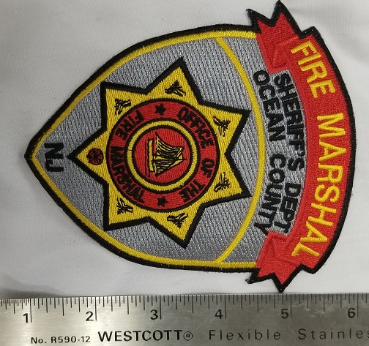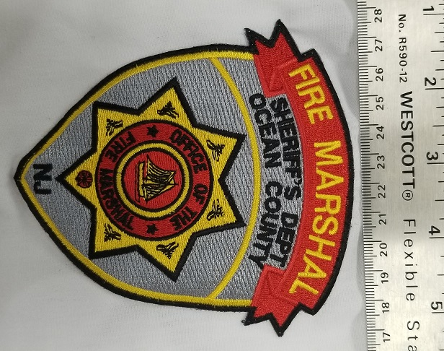

**SECTION V – RECRUIT UNIFORMS AND ACCESSORIES FOR THE SHERIFF'S OFFICE**

**ITEM #119 - BLACK LEATHER OXFORD SHOES**Manufacturer: Rothco #5085, or Equal

Color: Black

Style: Oxford

**ITEM #120 - CLIP-ON NECK TIE**

Manufacturer: Samuel Broome Style #450115, or Equal

Color: Black

Fabric: Polyester

Features: 3" Wide with button holes on the back side of the tie.

Sizes: 16” to 24

**ITEM #121 - LEATHER BELT**

Manufacturer: DeSantis #E22, **NO EXCEPTIONS**

Color: Black

Fabric: 1 ½” leather belt

Features: Silver or gold buckle as needed

Size: 24” through 48”

**ITEM #122 - NAME PLATE**

Nickel or Brass metal with black lettering, 2 ½” X ½” clutch back, First Initial and Last Name

**ITEM #123 - WATCH CAP**

Manufacturer: Pacific Headwear #621K, or Equal

Fabric: Acrylic Knit

Color: Black

**ITEM #124 - BASEBALL CAP**Manufacturer: Flexfit #6277, or Equal

Color: Black

**ITEM #125 - LONG SLEEVE KHAKI TWILL SHIRT**Manufacturer: VF-ST5CK, or Equal

Fabric: 65/35 Polyester/Cotton twill

Tailoring: Shirt must have sewn in military creases, 3 on back and 2 on front.

The Ocean County Police Academy patch must be sewn on left pocket.

The Ocean County Sheriff’s Office patch must be sewn on right shoulder by the vendor.

*Patch will be supplied by the Ocean County Sheriff’s Office*.

Shirts must be tapered to fit the individual.

**ITEM #126 - KHAKI TWILL TROUSERS**Manufacturer: VF-PT62KH, or Equal

Fabric: Polyester/ Cotton twill

Features: Trousers must have sewn-in crease on the front of each leg.

Tailoring: Trousers must be fitted to the individual.

**SECTION V – RECRUIT UNIFORMS AND ACCESSORIES FOR THE SHERIFF'S OFFICE (CONT’D)**

**ITEM #127 - GYM SHORTS**

Manufacturer: Augusta #990, or Equal

Fabric: 100% Cotton with Elastic waist

Color: Navy

Heat transfer: Last name in 2” Gold letters across rear seat centered OR proportionally sized as to fit the entire last name within the available area.

**ITEM #128 - CREW NECK T-SHIRT**Manufacturer: Hanes #5180W, or Equal

Fabric: 100% Cotton

Color: Navy

Heat transfer: Last name in 2” Gold letters across chest and back centered OR proportionally sized as to fit the entire last name within the available area.

**ITEM #129 - SWEAT PANTS**Manufacturer: Jerzees #562M, or Equal

Fabric: 50/50 Polyester/ Cotton

Features: Drawstring waist

Color: Navy

Heat transfer: Last name in 2” Gold letters across seat centered OR proportionally sized as to fit the entire last name within the available area.

**ITEM #130 - LONG SLEEVE CREW NECK SWEAT SHIRT**Manufacturer: Jerzees #973M, or Equal

Fabric: 50/ 50 Polyester/ Cotton

Color: Navy

Heat transfer: Last name in 2” Gold letters across chest and back centered OR proportionally sized as to fit the entire last name within the available area.

**ITEM #131 - TACTICAL PANTS**Manufacturer: Propper # F52525, or Equal

Fabric: 65% polyester / 35% cotton rip stop

Features: Two (2) coin pockets, cell phone pocket big enough for most smart phones, wrinkle-resist t and fade-resistant, snap closure with French fly, stretch waistband expands for easy movement, D- ring for tools and keys, includes matching belt.

Color: Black

Sizes: All

**ITEM #132 - WATERPROOF ECWCS PARKA**

Manufacturer: Tru-Spec H20 Proof Gen 2 Parka #2027, **NO EXCEPTIONS**

Color: Black

Size: XS –4X

Silk Screening: Back of jacket is to have reflective **SILVER** lettering to read: “OCEAN COUNTY”

(1st line, approx.1 ½” H) AND “SHERIFF” (2nd line, approx. 3” H).

**SECTION V – RECRUIT UNIFORMS AND ACCESSORIES FOR THE SHERIFF'S OFFICE (CONT’D)**

**ITEM #133 - WATERPROOF ECWCS TROUSERS**

Manufacturer: Tru-Spec H20 Proof Trousers #2046, **NO EXCEPTIONS**

Color: Black

Size: XS –4X

**ITEM #134 - MICRO FLEECE JACKET LINER**

Manufacturer: Tru-Spec Polar Fleece Jacket Liner #2437, **NO EXCEPTIONS**

Color: Black

Size: XS-4X

**ITEM #135 – TACTICAL GLOVES**Manufacturer: Rothco #3450, or Equal

Fabric: Synthetic leather

Color: Black

Sizes: All

**SECTION VI – UNIFORMS, EQUIPMENT & ACCESSORIES FOR THE SHERIFF'S OFFICE**

**ITEM #136 - LEATHER BELT**

Manufacturer: Done Hume, **NO EXCEPTIONS**

Material: Leather inner belt

Color: Black

Design: Plain

Fastener: Velcro

Size: 24”- 60” X 1 ¾” Wide

**ITEM #137 - LEATHER DUTY BELT**

Manufacturer: Done Hume, **NO EXCEPTIONS**

Material: Leather Outer Duty Belt

Color: Black

Design: Basket Weave

Fastener: Nickel or Brass buckle as required

Size: 24” – 60” X 2” Wide

**ITEM #138 - SHOULDER STRAP**

Manufacturer: Don Hume, **NO EXCEPTIONS**

Material: Leather

Color: Black

Design: Basket Weave

Hardware: Nickel or Brass as required

**ITEM #139 - SLIDING "D" RINGS**

Manufacturer: Don Hume, **NO EXCEPTIONS**

Material: Leather

Color: Black

Design: Basket Weave

Hardware: Nickel or Brass

Quantity: **PAIR**

**ITEM #140 - BELT KEEPERS**Manufacturer: Don Hume, **NO EXCEPTIONS**

Material: Leather

Color: Black

Design: Basket Weave

Hardware: Hidden snap

Quantity: **EACH**

**ITEM #141 - UNIVERSAL SWIVEL RADIO CASE**Manufacturer: Uncle Mikes, or Equal **(MUST FIT MOTOROLA APX6000 Li)**

Material: Leather

Color: Black

Design: Basket Weave

Hardware: Hidden snap or black snap

**ITEM #142 - NYLON RADIO CASE**

Manufacturer: Uncle Mikes, or Equal **(MUST FIT MOTOROLA APX6000 Li)**

Color: Black

Features: Nylon

**SECTION VI – UNIFORMS, EQUIPMENT & ACCESSORIES FOR THE SHERIFF'S OFFICE (CONT’D)**

**ITEM #143 - CLIP-ON NECK TIE**

Manufacturer:             Samuel Broome, Style #450115, or Equal

Color:                          Black

Fabric:                         Polyester/ Wool

Features:                     3" Wide with button holes on the backside of the tie.

Size:                            All sizes

**ITEM #144 - TIE BAR**

Nickel or gold with black lettering “Ocean (NJ STATE SEAL) County”

**ITEM #145 - NAME PLATE**

Manufacturer: Smith & Warren

Style: NP100

Color: Nickel or Brass metal

Features: Black lettering, 2 ½” X ½” clutch back, First Initial and Last Name

**ITEM #146 – UNIFORM TROUSERS, CLASS A**Manufacturer: Fechheimer/ Flying Cross, **NO EXCEPTIONS**

FEMALE style #X1 OCSTRSW01

MENS style #X1OCSTRS01

Color: Black

Fabric: 13- 13 ½ oz. / Linear yard, 55% Dacron/ 45% Wool, Serge,

Burlington Mills style #8330-561.

Features: Trouser shall be manufactured from a men’s uniform pattern. The trouser styling shall incorporate a plain front and straight leg bottoms. The trouser will have two straight side pockets, two hip pockets, a dropped watch pocket and one club pocket.

Customization: The trouser shall incorporate the following.

**STRIPING:** 1 ½” cloth stripe sewn into the seam over the front pocket into the waistband. Stripe shall be made from the Burlington Mill #503816 893E-00 Light Grey Heather to match the shirt.

**POCKETING:** Shall be 70% Polyester/ 30% Cotton, 2.9 oz. per square yard (60” width) with a minimum 78X64 count. Pocketing must have durable press finish and the color of the pocketing must be black in color. Two side pockets will have a minimum opening of 6 ¼” and a minimum depth of 5 ¾” measured from the bottom of the pocket opening. Side pockets shall have a firm straight bartacks at top and bottom of pocket openings (use of triangle bartacks will be cause for rejection). Pockets shall be constructed using the stitch, turn, and topstitch method. Pocket facings shall be made of the basic fabric and measure a minimum of 1 ½” from the bottom of the pocket opening. The watch pocket shall be located on the right front 1” below the waistband. This pocket shall have a minimum opening of ¾” depth of 3 ¾”. The front of the pocket shall be made of pocketing fabric and back of the pocket shall be made of basic fabric and the two pieces are securely stitched together. Each corner of the pocket opening shall have a firm straight bartacks. There shall be a club pocket located 5 ¼” (plus or minus ¼”) from the side seam with a minimum opening of 3 ½” and minimum depth of 8”. Pocketing material to be the same as side and hip pockets. Club pocket shall be constructed using the double welt method on a REECE PW machine and finished in such a manner that there is no topstitching (topstitched club pockets shall be cause for rejection). *The corners of the club pocket shall have firm straight bartacks for reinforcing strength. Use of triangle bartacks will be cause for rejection.*

**SECTION VI – UNIFORMS, EQUIPMENT & ACCESSORIES FOR THE SHERIFF'S OFFICE (CONT’D)**

**ITEM #146 – UNIFORM TROUSERS, CLASS A (Cont’d)**

**FLY:** Trouser shall have a metal memory lock zipper. There shall be a French Fly tab closure on the inside the right fly. The tab shall be double ply made of the basic cloth (tabs made of pocketing material or a “grown on” French Fly will be cause for rejection). The right fly shall be lined with the same fabric as the waistband curtain and pocketing. The fly lining shall be sewn to the left fly below the zipper in a neat and durable manner. A button shall be located on the left fly corresponding with the French Fly tab to provide a clean and comfortable closure. There shall be a firm straight bartack at the bottom of fly going through the zipper tape.

**BELT LOOPS:**There shall be a minimum of 7 interlined ¾” wide belt loops. All loops shall be tacked to the trouser ½” below the bottom of the waistband. The top of the belt loops (except for the center back loop) shall be caught into the waistband curtain seam with a Rocap machine. The top of the center back loop shall be tacked to the outside of the waistband. **WAISTBAND:** The waistband shall be constructed using the “closed method” and shall measure a minimum of 2” wide when finished. The waistband curtain shall finish a minimum 2 1/8” wide and is to be made of the same fabric and color as the pocketing material and shall be attached to the top of the trouser with a zigzag stitch. The waistband curtain must contain Tru-Grip, a ½” surface area composed of thin 55 gauge rubber for maximum comfort and performance. The Tru-Grip acts to help keep the shirt tucked in securely. (Substitution of a silicone strip or strips in place of Tru-Grip shall not be acceptable and cause for rejection). The waistband curtain is composed of a wet laid non-woven canvas weighing 3.3 oz. per square yard. The canvas is covered in the same color and material as the pocketing. The ½” rubberized surface area is positioned

1 ¼” up from the bottom of the curtain. The specifications for the rubberized Tru-Grip curtain are as follows: (Width: 1 1/8”, Warp: 300 Denier Texturized Polyester, Filling: 300 Denier Texturized Polyester, Rubber: 55 gauge, Count: 32-36 yarns per inch, Contents: 59% Polyester/ 41% Rubber). The waistband must contain ¾” Ban-Rol to prevent roll over at the trouser front. The waistband closure shall be accomplished with a single crush proof hook and eye centered on the waistband for wearer comfort. The hook and eye shall be reinforced with 7/8” non-woven stay tape that is anchored with the topstitching through and through to the top of the waistband (bartacks in place of topstitching shall be cause for rejection). In addition to the stitching of the waistband when it is set onto the trouser, the waistband must also be topstitched below the waistband seam through the waistband curtain for added strength. The back center seam of the trouser is to be finished to allow for alterations (with ample basic fabric and waistband curtain material to allow trouser size to be increased at least one size). The outlet in the seat is to be in proportion to the waist outlet so seat may also be let out. Seat seam must be sewn with a tandem needle machine (double-needle stitch) for maximum strength.

**STITCHING, PRESSING & FINISHING**: Trouser must be stitched with matching thread and all stitching to show must be 10-11 stitches per inch. Trouser must be neatly pressed on Hothead Presses and properly shaped. Out seams and inseams must be pressed open. Trouser must be cleaned and finished to eliminate loose threads.

**LABELS:** Trouser must have a care label permanently affixed that also indicates the size. A paper ticket showing the size, fabric content, cut number, and WPL number must be on the outside of the waistband.

Standard Size: Men's regular length: even waist sizes 28-50; odd waist sizes 29-37 Women's regular length: even sizes 2-24

**SECTION VI – UNIFORMS, EQUIPMENT & ACCESSORIES FOR THE SHERIFF'S OFFICE (CONT’D)**

**ITEM #146 – UNIFORM TROUSERS, CLASS A (Cont’d)**

Quantities/ Tailoring: This bid line item is for **EACH** pair of pants and for an estimated minimum quantity of 200 Class A Uniform Trousers. Specific sizes totaling the quantity of 200 or more will be delivered to the vendor at the time of ordering. **Please refer to ADJUSTMENTS AND ALTERATIONS & UNIFORM FITTING in the beginning of this bid for tailoring requirements.**

**ITEM #147 – UNIFORM SHIRT LONG SLEEVE, CLASS A**

Manufacturer: Fechheimer/ Flying Cross, **NO EXCEPTIONS**

FEMALE style #X1238W7161

MENS style #X1338W7161

Color: Light Grey Heather

Fabric: Burlington Mills #503816 893E-00

Style: Uniform shirt with single pointed western yoke and reinforced elbows. Dress style, top center placket front with the zipper, full cut tapered fit, banded collar, long sleeves with barrel cuffs, and dress shirttail. Two pleated breast pockets with topstitched scalloped flaps. Topstitched shoulder straps. Full badge patch. Matching inside yoke and band of high lustre PolyTwill.

Features: **COLLAR & STRAND**: Collar points to measure 3” long with ultrasonically fused-in Mylar stays. Collar to have woven interlining of #250 Dacron. Stays to be 2 ¾” long, 3/8” minimum width, and to be fused to underside of collar interlining. Stays applied directly to collar material itself unacceptable. Collar height at rear 1 ½”. Collar topstitched ¼” off the edge. Collar stand to measure 1 5/16” at rear and band to be interlined with “Crease-N-Tack”. Collar material itself (top or underside) shall have no fusing to Mylar stays or collar interlining.

FRONT: The left front shall have a top center placket 1 ½” wide with two rows of stitches 7/8” apart. The shirt will have 7 button and buttonholes on the front; spacing between each will be 3 ¾” except the spacing between the neck button and the first button on the front, which will be approximately 3 ¼”. Top center placket to have woven interlining of #250 Dacron. Non-woven interlining unacceptable and shall be cause for rejection. The fronts shall be joined to the yoke so that both raw edges of the yoke are turned under, with the front sandwiched between, and then all three are stitched down with a 1/16” raised stitch. Safety stitch joining unacceptable. A 15” nylon zipper, to be set below the second button and buttonhole, shall accomplish front closure. The top, second and bottom buttons to be attached to the right front, the balance to be sewn over the buttonholes on the left front. The shirt shall incorporate a metal button feature on the epaulets, pocket flaps and down the front placket. The shirt shall have New Jersey State seal buttons, gunmetal grey.

**SHOULDER STRAPS:** Shoulder straps to be two-piece pointed, ¼” topstitched and to be set on yoke with leading topstitch conforming to the front joining and set not more than ½” from the collar set seam. Cross-stitched approximately 2” from the sleeve seam. Shoulder strap to have functional buttonhole to attach to metal button on shoulder of shirt. Edge stitched shoulder strap construction unacceptable.

**BADGE REINFORCEMENT**: A badge patch shall be applied to the left front panel of the shirt. The patch shall have two metal eyelets spaced 1 ¼” apart from center to center. The badge patch shall be approximately 1” wide by 2” long and stitched on all sides.

**SECTION VI – UNIFORMS, EQUIPMENT & ACCESSORIES FOR THE SHERIFF'S OFFICE (CONT’D)**

**ITEM #147 – UNIFORM SHIRT LONG SLEEVE, CLASS A (Cont’d)**

**POCKETS:** Two breast patch pockets with mitered corners and 1 ½” stitched pleats. Pleats shall be stitched top and bottom and full length of pleat to prevent spreading. Pocket to measure 5 5/8” wide, 6” deep. Left breast pocket to have 1 ½” pencil stitch. Each pocket to have hook Velcro, edges of pocket to correspond with outer scalloped flap points as specified. Velcro to be stitched all sides and to be sewn through pocket and shirt for added reinforcement.

**FLAPS:** Two piece deep scalloped design to measure 5 7/8” across and 2 ¾” in depth at the center point, 2 ¼” at sides. Secured to shirtfront approximately 3/8” above pocket. Left flap to have invisible pencil opening 1 ½” to correspond precisely with pencil slot of pocket. (Stop & start stitching for pencil opening unacceptable and shall be cause for rejection.) Flaps to be ¼” topstitched. Flaps to have woven interlining of #250 Dacron. Creased and edge stitched pocket flap construction unacceptable. Under side of the flap to have looped Velcro ¾” long by ½” wide stitched all sides, positioned on outer points of both pocket flaps to secure with corresponding Velcro strips on shirt pocket. Each flap shall have a button centered on uncut sewn buttonhole.

**SLEEVES:** To be long sleeves with approximate 4 ½” sleeve vent. Sleeve shall have a one-piece, elbow reinforcement and vent facing. Elbow reinforcement shall extend into the sleeve-closing seam.

**CUFFS:** Two piece ½” hemmed cuff with ¼” topstitching. Cuffs to measure 3” in depth with rounded corners (barrel cuffs). Cuffs to have two buttons and corresponding buttonholes set vertically with on button and buttonhole in center of facing. Cuffs to have woven interlining of #250 Dacron.

**BUTTONS:** NJ State Seal, Gunmetal

WIRE PASS THROUGH OPENINGS: Each front shall have an 11/16” horizontal buttonhole to be centered vertically and horizontally between the top of the pocket and the bottom of the open flap. Each shoulder shall have an 11/16” horizontal buttonhole to be centered under the shoulder straps and sewn through the shoulder of the shirt. Each side seam shall have an 11/16” vertical eyelet.

**SEWING:** Collar, shoulder straps, pocket flaps and cuffs to be topstitched ¼” off the edge. Sleeve inserting and side close felling seams are to be safety stitched.

**THREAD**: All sewing threads to be colorfast polyester wrap to match.

**INTERLININGS**: Collar, cuffs, pocket flaps and top center to be interlined with #250 Dacron. Collar band interlining to be “Crease-N-Tack”.

**MILITARY CREASES**: There shall be five stitched-in sharp military creases on all shirts. One crease on each front to be centered vertically. Front creases shall not be through pockets and flaps. Spacing for three military creases across shirt back to be proportionate to the size of the shirt.

**CONSTRUCTION**: Collars, flaps and cuffs are made with conventional construction. Top ply, bottom ply and interlining are first stitched together, then turned right side out and finally topstitched.

**FEMALE LONG SLEEVE SHIRT**: Shall be made like the male shirt except cut on a female pattern using feature dimensions for a female shirt.

**PATCHES**: **Shoulder patch** sewn onto left and right shoulders.

Quantities/ Tailoring: This bid line item pricing is for **EACH** shirt and for an estimated minimum quantity of 200 Class A Uniform **LONG** sleeve shirts. Specific sizes & types (men’s or women’s) totaling a quantity of 200 or more will be delivered to the vendor at the time of ordering. **Please refer to ADJUSTMENTS AND ALTERATIONS & UNIFORM FITTING in the beginning of this bid for tailoring requirements.**

**SECTION VI – UNIFORMS, EQUIPMENT & ACCESSORIES FOR THE SHERIFF'S OFFICE (CONT’D)**

**ITEM #147 – UNIFORM SHIRT LONG SLEEVE, CLASS A (Cont’d)**

Size: **MEN’S LONG SLEEVE:** NECK SIZE: 15 thru 21

SLEEVE LENGTH: 32 thru 37

**WOMEN’S LONG SLEEVE:** 28 thru 44

Patches: Two patches (one on each shoulder) will be applied, centered and sewn 1” down from shoulder seam.*Only shoulder patches shall be supplied by the County.* ***IF RANK INSIGNIA IS REQUIRED*** *specific rank insignia will be designated on the Purchase Order. ALL rank insignias shall be supplied by and sewn* ***by the vendor.***

**ITEM #148 – UNIFORM SHIRT SHORT SLEEVE, CLASS A**

Manufacturer: Fechheimer/ Flying Cross, **NO EXCEPTIONS**

FEMALE style #X1 687R7161

MENS style #X1 287R7161

Color: Light Grey Heather

Quantities/ Tailoring: This bid line item pricing is for **EACH** shirt and for an estimated minimum quantity of 150 Class A Uniform **SHORT** sleeve shirts. Specific sizes & types (men’s or women’s) totaling a quantity of 150 or more will be delivered to the vendor at the time of ordering. **Please refer to ADJUSTMENTS AND ALTERATIONS & UNIFORM FITTING in the beginning of this bid for tailoring requirements.**

Fabric: Burlington Mills #503816 893E-00

MALE SHORT SLEEVE SHIRT: The short sleeve shirt shall be made like the long sleeve except have a “Convertible Collar” design.

FEMALE SHORT SLEEVE SHIRT: Shall be made like the male shirt except cut on a female pattern using feature dimensions for a female shirt.

EMBLEMS: Long sleeve and short sleeve shirts shall have two emblems applied, centered and sewn 1” down from the shoulder seam by the vendor but supplied by the agency.

Size: **MEN’S SHORT SLEEVE:** SMALL through 4X

**WOMEN’S SHORT SLEEVE:** 28 thru 44

Patches: Two patches (one on each shoulder) will be applied, centered and sewn 1” down from shoulder seam. *Only shoulder patches shall be supplied by the County.* ***IF RANK INSIGNIA IS REQUIRED*** *specific rank insignia will be designated on the Purchase Order. ALL rank insignias shall be supplied by and sewn* ***by the vendor.***

**ITEM #149 - BDU TROUSERS, CLASS B**Manufacturer: Elbeco Reflex BDU Pants, **NO EXCEPTIONS**

**Men’s #E7360R/ Women’s #E7370LC**

Fabric: 65% Polyester/ 35% Cotton RipStop with 12% Fiber Stretch

Weight: 6.5 oz. / sq. yard

Features: Permanent Nano Fluid Repellency allows fluids to bead and roll off fabric. Hidden cargo styles have internal compartments and zippered closures. External cargo styles have notched front pockets with knife clip reinforcements, utility pockets and magnet closures on flaps. Covert flex waistband provides 2” stretch while holding up duty belt. Diamond-shaped crotch gusset provides comfort and mobility. UPF 50 protection reduces damage from sun.

Customization: 1.5" grey stripe (Color must match shirt fabric of BLAUER 8703X) on outside of both pant legs and length of pants.

Standard Size: Men's regular length: even waist sizes 28-54; odd waist sizes 31-37 Women's regular length: even dress sizes 6-24

**SECTION VI – UNIFORMS, EQUIPMENT & ACCESSORIES FOR THE SHERIFF'S OFFICE**

**(CONT’D)**

**ITEM #150 - BDU LONG SLEEVE SHIRT, CLASS B**

Manufacturer: Blauer 8670, **NO EXCEPTIONS**

Color: Grey (12) with Name Strip (first letter of first name, period, last name, all capitalized)

Name Strip: 1 1/8” wide, same gray fabric as shirt, stitched on, black letters, letter size ¾” (may vary due to name size or length) First Initial, Last Name.

Fabric: 11 oz. twill weave washable cotton blend fabric with 10% stretch and liquid repellent finish.

Features: Pleated pockets with scallop flaps, pencil slot left, and hook-and-loop closure, convertible sport collar, traditional 5-crease military style (stitched), 2-button adjustable cuffs, epaulets, extra-long shirt tails

Size: **Men’s**: Body length Sleeve Length Size

REGULAR SHORT (31-32) S-XL

REGULAR REGULAR (32.5-33.5) S-XXXXL

REGULAR REGULAR (34-35) M- XXXXL

TALL X- LONG (35.5-36.5) L-XXXXL

**Women’s**: REGULAR XS-XXXL

Patches: **Sheriff’s Star Badge patch** over left breast pocket, **Color shall be silver for officers and gold for ranks of corporal and above. Shoulder patch** sewn onto left and right shoulders. *Only shoulder patches shall be supplied by the County.* ***IF RANK INSIGNIA IS REQUIRED*** *specific rank insignia will be designated on the Purchase Order. ALL rank insignias shall be supplied by and sewn* ***by the vendor.***

**ITEM #151 - BDU SHORT SLEEVE SHIRT, CLASS B**Manufacturer: Blauer 8675, **NO EXCEPTIONS**

Color: Grey (12) with Name Strip (first letter of first name, period, last name, all capitalized)

Name Strip: 1 1/8” wide, same gray fabric as shirt, stitched on, black letters, letter size ¾” (may vary due to name size or length) First Initial, Last Name

Fabric: 11 oz. twill weave washable cotton blend fabric with 10% stretch and liquid repellent finish.

Features: Pleated pockets with scallop flaps, pencil slot left, and hook-and-loop closure, convertible sport collar, traditional 5-crease military style (stitched), 2-button adjustable cuffs, epaulets, extra-long shirt tails

Size: Men’s Regular Sizes in S-4XL, and Tall in L-4XL; Women’s Regular Sizes XS-3XL

Patches: **Sheriff’s Star badge patch** over left breast pocket, **Color shall be silver for officers and gold for ranks of corporal and above. Shoulder patch** sewn onto left and right shoulders.*Only shoulder patches shall be supplied by the County.* ***IF RANK INSIGNIA IS REQUIRED*** *specific rank insignia will be designated on the Purchase Order. ALL rank insignias shall be supplied by and sewn* ***by the vendor.***

**SECTION VI – UNIFORMS, EQUIPMENT & ACCESSORIES FOR THE SHERIFF'S OFFICE (CONT’D)**

**ITEM #152 - TURTLENECK**

Manufacturer: Fechheimer, Style #52610, or Equal

Color: Black

Fabric: The turtleneck shirt shall be made throughout the body and collar, from a 4-way stretch (90% Cotton 10% Lycra) 28 cut jersey knit fabric made from 30/1 combed ring spun Cotton an 70/1 Spandex Lycra. The fabric shall be dyed with reactive dyes for maximum color retention.

Weight: 6.25-6.75 oz. per square yard

Shrinkage: Warp: 5% (max.) Filling: 5% (max.)

Wales per Inch: 37

Courses per Inch: 52

Tape Reinforcement: 100% Polyester woven tape, 0.25 inches wide. The shoulders shall be reinforced with the specified Tape to prevent these seams from coming apart under stress. The tape shall be the entire length of the shoulder seam and be caught in the collar attaching seam and the sleeve-setting seam

Thread: 100% Polyester size #70

General Design: The turtleneck shirt shall be a close-fitting pullover style with set in shoulders and attached turtleneck color and cuffs using on ply of the specified stretch fabric for the body and sleeves with the two plies of the specified fabric for the color and cuffs. The collar shall be interlined with one ply of fusible stretch interlining. The bottom of the body shall finish in a concave arc at the back and a convex arc in the front with the back at the center longer than the front at the center by two and a half inches.

Construction: All turtleneck joining seams shall be stitched using an over-lock machine.

All seams shall be straight and clean with thread ends trimmed.

Labeling: Garments shall be permanently labeled with origin, size, care and contents.

Size: S-4XL and shall fit both male and female officers

Customization: **¾” Block letter “SHERIFF” embroidered on neck in gold #9001 thread.**

**SECTION VI – UNIFORMS, EQUIPMENT & ACCESSORIES FOR THE SHERIFF'S OFFICE (CONT’D)**

**ITEM #153 - LONG SLEEVE SPORT T-SHIRT**

Manufacturer: Sport Tek, Long sleeve t shirt, #ST350LS, or Equal

Color: All Available

Fabric: 3.8 ounce, 100% Spun polyester jersey

Features: color locking, moisture wicking, matte finish, set-in sleeves.

Size: XS –4XL

Silk Screening: **Sheriff’s Logo on left chest *AND* back,** **DIAGRAM/LOGO TO BE USED WILL BE INDICATED ON THE PURCHASE ORDER**

**ITEM #154 - SHORT SLEEVE SPORT T-SHIRT**

Manufacturer: Sport Tek, Short sleeve t shirt, #ST350, or Equal

Color: All available

Fabric: 3.8 ounce, 100% Spun polyester jersey

Features: color locking, moisture wicking, matte finish, set-in sleeves.

Size: XS –4XL

Silk Screening: **Sheriff’s Logo on left chest *AND* back,** **DIAGRAM/LOGO TO BE USED WILL BE INDICATED ON THE PURCHASE ORDER**.

**ITEM #155 - HOODED SWEATSHIRT**

Manufacturer: Sport Tek, Repel fleece hooded pullover, #ST290, or Equal

Color: All available.

Fabric: 100% Polyester

Features: Color locking, moisture wicking, Three-panel hood with dyed-to-match open-hole mesh lining Silicon grommets and dyed-to-match draw cord Seaming accent at sleeves Self-fabric cuffs and hem Front pouch pocket

Size: XS- 4X

Silk Screening: **Sheriff’s Logo on left chest *AND* back,** **DIAGRAM/LOGO TO BE USED WILL BE INDICATED ON THE PURCHASE ORDER**.

**ITEM #156 - FLEECE PANTS**

Manufacturer: Sport Tek, Sport wick fleece pants, #ST237, or Equal

Color: All available.

Fabric: 100% Polyester

Features: Color locking, moisture wicking, elastic waistband and dyed-to-match draw cord, Front slash pockets, open hem cuffs.

Size: XS- 4X

Silk Screening: Sheriff’s Logo on left leg, **DIAGRAM/LOGO TO BE USED WILL BE INDICATED ON THE PURCHASE ORDER**.

**ITEM #157 - POCKETED SHORTS**

Manufacturer: Sport Tek PosiCharge competitor pocketed short, #ST355P, or Equal

Color: All available.

Fabric: 3.8 ounce, 100% Polyester

Features: Color locking, moisture wicking, elastic waistband and dyed-to-match draw cord, Front slash pockets.

Size: XS- 4X

Silk Screening: Sheriff’s Logo on left leg, **DIAGRAM/LOGO TO BE USED WILL BE INDICATED ON THE PURCHASE ORDER**.

**SECTION VI – UNIFORMS, EQUIPMENT & ACCESSORIES FOR THE SHERIFF'S OFFICE (CONT’D)**

**ITEM #158 – HONOR GUARD DRESS BLOUSE**

Style: Custom Style 400 Single Breasted Jacket, **NO EXCEPTIONS**

Color: Black

Material: Black Elastique (55/45 Poly/ wool 16.5 oz./ 17 oz. XX-605-BLACKCB

Primary Features: Notch lapel, bi- swing back, tapered waist with black hooks on front and back (total 4),

No vents, front vertical darts, cloth badge holder, fully lined jacket, double stitching, no edgecord, shoulder strap same material as jacket.

Pockets and Flaps: 3 point flaps (same material as jacket), upper pleated patch pockets, straight flaps (same material as jacket), lower set in pockets with double welt (must include flaps), double welted inside pockets on left and right sides.

Buttons: Gun metal (NJ), 4 buttons down front.

Stripe Material: Grey 100% Polyester whipcord- MJ-6248-022R (Raefords) ¼” fabric stripes, 1 row on each sleeve no edgecord.

**ITEM #159 – HONOR GUARD DRESS PANTS**

Style: Custom Style 450 Trousers, **NO EXCEPTIONS**

Material: Black Elastique (55/45 Poly/ wool 16.5 oz./ 17 oz. XX-605-BLACKCB

Primary Features: To be in design and function exactly as our CLASS A Uniform Trousers with the exception of using the material as used in the Honor Guard Dress Blouse.

Striping: 1 ½” grey stripe as used on Class A Shirt Material and sewn on trousers from the waistband down.

**ITEM #160 – HONOR GUARD DRESS SHOES**

Style: Bates High Gloss Durashocks Oxford, **NO EXCEPTIONS**

Color: Black

**ITEM #161 – HONOR GUARD DRESS GLOVES**

Style: Vanguard Gloves, **NO EXCEPTIONS**

Color: White

Sizes: ALL

**ITEM #162– FELT CAMPAIGN HAT**

Style: Stratton Hat Brim w/ one badge eyelet, **NO EXCEPTIONS**

Color: Black

**ITEM #163 – HEAD STRAP 1 PIECE FOR STRATTON HATS**

Style: Black, leather with either gold or nickel buckle, **NO EXCEPTIONS**

**ITEM #164 – HEAD STRAP 3 PIECE FOR STRATTON HATS**

Style: Black, leather with either gold or nickel buckle, **NO EXCEPTIONS**

**ITEM #165 - STRATTON HAT BRIM PRESS**

Style: STRATTON HAT TRAP, **NO EXCEPTIONS**

**SECTION VI – UNIFORMS, EQUIPMENT & ACCESSORIES FOR THE SHERIFF'S OFFICE (CONT’D)**

**ITEM #166 - BIKE PATROL/ MARINE UNIT SHORT SLEEVE POLO, MENS**

Manufacturer: BLAUER, #8133 Short Sleeve, **NO EXCEPTIONS**

Color: HI VIS YELLOW

Size: XS –4XL

Patch: **Sheriff’s Star Badge patch** over left breast pocket, **Color shall be silver for officers**

**and gold for ranks of corporal and above**.

Heat Transfer: Back of shirt is to have **BLACK** lettering to read: “OCEAN COUNTY”

(1st line, approx. 1 ½” H) AND “SHERIFF” (2nd line, approx. 3” H).

Name strip above right pocket: First Initial, Last Name

**ITEM #167 - BIKE PATROL/ MARINE UNIT LONG SLEEVE POLO, MENS**

Manufacturer: BLAUER, #8143 Long Sleeve, **NO EXCEPTIONS**

Color: HI VIS YELLOW

Size: XS –4XL

Patch: **Sheriff’s Star Badge patch** over left breast pocket, **Color shall be silver for officers**

**and gold for ranks of corporal and above**.

Heat Transfer: Back of shirt is to have **BLACK** lettering to read: “OCEAN COUNTY”

(1st line, approx. 1 ½” H) AND “SHERIFF” (2nd line, approx. 3” H).

Name strip above right pocket: First Initial, Last Name

**ITEM #168 - BIKE PATROL/ MARINE UNIT PANTS, MENS**

Manufacturer: BLAUER, #8822Z, **NO EXCEPTIONS**

Material: 88% Nylon/ 12% Spandex FlexForce fabric with 4 way stretch. Water resistant FlexForce Fabric, wind resistant, breathable FlexForce fabric, odor control technology, UPF 30 UV protection, 2 Front on seam pockets, 2 side seam zipped cargo pockets w/ internal magazine pockets, 1 R side zippered hip pocket.

Color: Black

Size: 28-46

**ITEM #169 - BIKE PATROL/ MARINE UNIT PANTS, WOMENS**

Manufacturer: BLAUER, #8822WZ, **NO EXCEPTIONS**

Material: 88% Nylon/ 12% Spandex FlexForce fabric with 4 way stretch. Water resistant FlexForce Fabric, wind resistant, breathable FlexForce fabric, odor control technology, UPF 30 UV protection, 2 Front on seam pockets, 2 side seam zipped cargo pockets w/ internal magazine pockets, 1 R side zippered hip pocket.

Color: Black

Size: 02-26

**ITEM #170 - BIKE PATROL/ MARINE UNIT JACKET, MEN’S**

Manufacturer: BLAUER, #360, **NO EXCEPTIONS**

Color: HI VIS YELLOW

Size: XS-4XL, Short, Regular, Tall

Patch: **Sheriff’s Star Badge patch** over left breast pocket, **Color shall be silver for officers**

**and gold for ranks of corporal and above**.

Heat Transfer: Back of jacket is to have **BLACK** lettering to read: “OCEAN COUNTY”

(1st line, approx. 1 ½” H) AND “SHERIFF” (2nd line, approx. 3” H).

**SECTION VI – UNIFORMS, EQUIPMENT & ACCESSORIES FOR THE SHERIFF'S OFFICE (CONT’D)**

**ITEM #171 - BIKE PATROL TACTICAL SHOES**

Manufacturer: HAIX BLACK EAGLE TACTICAL 2.0 LOW #300101, **NO EXCEPTIONS**

Material: Waterproof leather, Gore-Tex inside, durable sole, smart lacing, antibacterial insole, metal free, moisture wicking, antistatic.

Color: BLACK

Size: 4-16, Medium, Wide

**ITEM #172 – MARINE UNIT TACTICAL SHOES**

Manufacturer: Columbia Drainmaker IV Water Shoe, **NO EXCEPTIONS**

Material: Waterproof leather, Gore-Tex inside, durable sole, smart lacing, antibacterial insole, metal free, moisture wicking, antistatic.

Color: BLACK

Size: 7-15, Medium, Wide

**ITEM #173 – UNIFORM HAT, CLASS A, OFFICERS/ CPL.**

Manufacturer: Hamburger Woolen #420, or Equal

Material: 100% Dacron Polyester, 12 oz. Serge

Color: Black

Style: Pershing style with permanent sewn in wire. Hatband to be 2 1/2” wide. Visor to be 1 5/8” long with sharp drop. Hat to have 25 ligne silver metal and black plastic chinstrap across front. Cap to have extra saddle leather overhead strap and leather sweatband. New Jersey Seal gun-metal buttons

**ITEM #174 – UNIFORM HAT, CLASS A, SGT., LT., CAPT., US, SHERIFF3**

Manufacturer: Hamburger Woolen #420, or Equal

Material: 100% Dacron Polyester, 12 oz. Serge

Color: Black

Style: Pershing style with permanent sewn in wire. Hatband to be 2 1/2” wide Visor to be 1 5/8” long with sharp drop, hat to have 25 ligne metal buckle.

Cap to have extra saddle leather overhead strap with **GOLD** buckle and leather sweatband. New Jersey Seal **GOLD** buttons.

**GOLD METAL** snake across front for Sgt. ONLY.

**GOLD NYLON** band across front for Lt. and above.

**CUSTOMIZED BRIM FOR CAPT. AND ABOVE ONLY.**

**ITEM #175 - HAT COVER, REVERSIBLE, UNISEX**Manufacturer: Blauer #107, or Equal

General design: Waterproof Tech-lite urethane-coated 200-denier nylon oxford fabric. Elasticized edge

Color: Reverses to black and hi-vis yellow

**ITEM #176 – CAP STYLE #1**

Manufacturer: Flexfit Ultrafibre #6530, or Equal

Fabric: 84% Nylon, 14% Cotton, 2% Spandex

Color: Black

Size: One size fits all

Embroidery: Sheriff’s Logo on left chest**, DIAGRAM/LOGO TO BE USED WILL BE INDICATED ON THE PURCHASE ORDER**

**SECTION VI – UNIFORMS, EQUIPMENT & ACCESSORIES FOR THE SHERIFF'S OFFICE**

**(CONT’D)**

**ITEM #177 – CAP STYLE #2**Manufacturer: Flexfit #6277, or Equal

Color: Black

Embroidery: Sheriff’s Logo**, DIAGRAM/LOGO TO BE USED WILL BE INDICATED ON THE PURCHASE ORDER.**

**ITEM #178 – WINTER HAT**

Manufacturer: CONDOR FLEECE #WC, **NO EXCEPTIONS**

Fabric: Synthetic micro fleece

Color: BLACK,

Embroidery: Sheriff’s Logo**, DIAGRAM/LOGO TO BE USED WILL BE INDICATED ON THE PURCHASE ORDER.**

**ITEM #179 - SHORT SLEEVE POLO SHIRT, CLASS C**

Manufacturer: Vertex VTX4000P (Men's) & VTX4010P (Women's), **NO EXCEPTIONS**

Fabric: 100% Antimicrobial Performance Synthetic, polyester-pique knit

Weight: 6 ½ oz.

Style: Side gussets and raglan sleeves add comfort and complete mobility

Features: Durable mesh fabric provides high-performance breathability, moisture transport wicking, No-roll collar, three (3) button placket front with mic tab/sunglasses loop,

Dual pen/pencil pocket on left sleeve

Color: Grey, Red

Size: Men’s & Women’s sizing XS-4XL

Embroidery: Sheriff’s Logo on left chest**, DIAGRAM/LOGO TO BE USED WILL BE INDICATED ON THE PURCHASE ORDER.**

Silk Screening: Back of shirt is to have reflective **SILVER** lettering to read: “OCEAN COUNTY”

(1st line, approx.1 ½” H) AND “SHERIFF” (2nd line, approx. 3” H).

**ITEM #180 - LONG SLEEVE POLO SHIRT, CLASS C**

Manufacturer: Vertex VTX4020P (Men's) & VTX4030P (Women's), **NO EXCEPTIONS**

Fabric: 100% Antimicrobial Performance Synthetic, polyester-pique knit

Weight: 6 ½ oz.

Style: Side gussets and raglan sleeves add comfort and complete mobility

Features: Durable mesh fabric provides high-performance breathability, moisture transport wicking, No-roll collar, three (3) button placket front with mic tab/sunglasses loop,

Dual pen/pencil pocket on left sleeve

Color: Grey, Red

Size: Men’s & Women’s sizing XS-4XL

Embroidery: Sheriff’s Logo on left chest**, DIAGRAM/LOGO TO BE USED WILL BE INDICATED ON THE PURCHASE ORDER.**

Silk Screening: Back of shirt is to have reflective **SILVER** lettering to read: “OCEAN COUNTY”

(1st line, approx.1 ½” H) AND “SHERIFF” (2nd line, approx. 3” H).

**SECTION VI – UNIFORMS, EQUIPMENT & ACCESSORIES FOR THE SHERIFF'S OFFICE (CONT’D)**

**ITEM #181 - SHORT SLEEVE PERFORMANCE POLO SHIRT**Manufacturer: Propper ICE Performance Polo #F5341, or Equal

Features: Advanced moisture-wicking fabric with hidden collar stays and gusseted mesh underarms

Color: Black, Red, Cobalt Blue, Grey

Size: S-4XL

Embroidery: Sheriff’s Logo on left chest**, DIAGRAM/LOGO TO BE USED WILL BE INDICATED ON THE PURCHASE ORDER**.

**ITEM #182 - LONG SLEEVE PERFORMANCE POLO SHIRT**

Manufacturer: Propper ICE Performance Polo #F5315, or Equal

Features: Advanced moisture-wicking fabric with hidden collar stays and gusseted mesh underarms.

Color: Black, Red, Cobalt Blue, Grey

Size: S-4XL

Embroidery: Sheriff’s Logo on left chest**, DIAGRAM/LOGO TO BE USED WILL BE INDICATED ON THE PURCHASE ORDER**.

**ITEM #183 - COMBAT SHIRT, STYLE #1**

Manufacturer: Vertex, Recon combat shirt #VTX8525, or Equal

Features: Added fabric space in rip-stop cotton sleeves, Double-reinforced and double-articulated elbows, Dual loop VELCRO® bicep pockets provide large storage capacity for extra carrying materials and patching purposes, Additional pen pocket is ergonomically located inside each bicep pocket, Quarter-zip suede collar yields extra neck and throat protection

Color: All colors

Size: XS- 4X

Embroidery: Sheriff’s Logo on left chest**, DIAGRAM/LOGO TO BE USED WILL BE INDICATED ON THE PURCHASE ORDER**.

**ITEM #184 - COMBAT SHIRT, STYLE #2**

Manufacturer: First Tactical Defender Shirt Long Sleeve #111004 &

First Tactical Defender Shirt Short Sleeve #112017, or Equal

Color: All Colors

Size: S – 4X/ L-4X Tall

Embroidery: Sheriff’s Logo on left chest**, DIAGRAM/LOGO TO BE USED WILL BE INDICATED ON THE PURCHASE ORDER**.

**ITEM #185 - COMBAT SHIRT, STYLE #3**

Manufacturer: First Tactical Defender Shirt Long Sleeve #111004MC &

First Tactical Defender Shirt Short Sleeve #117201MC, or Equal

Color: **MULTI CAM**

Size: S – 4X/ L-4X Tall

Embroidery: Sheriff’s Logo on left chest**, DIAGRAM/LOGO TO BE USED WILL BE INDICATED ON THE PURCHASE ORDER**.

**SECTION VI – UNIFORMS, EQUIPMENT & ACCESSORIES FOR THE SHERIFF'S OFFICE (CONT’D)**

**ITEM #186 - MENS/ WOMENS DRESS SHIRT LONG SLEEVE**Manufacturer: Edwards, or Equal

Fabric: 100% Preshrunk Cotton Wrinkle free.

Color: White or Black

Style: Waffle weave, button down collar, long sleeve.

Size: Mens and Womens sizing ALL

Embroidery: Sheriff’s Logo on left chest**, DIAGRAM/LOGO TO BE USED WILL BE INDICATED ON THE PURCHASE ORDER**

**ITEM #187 - TACTICAL PANTS, STYLE #1**Manufacturer: Propper # F52525, or Equal

Fabric: 65% polyester / 35% cotton rip stop

Features: Two (2) coin pockets, cell phone pocket big enough for most smart phones,

wrinkle-resistant and fade-resistant, snap closure with French fly, stretch waistband expands for easy movement, D-ring for tools and keys, includes matching belt.

Color: Black, charcoal or khaki

Sizes: All

**ITEM #188 - TACTICAL PANTS, STYLE #2**

Manufacturer: Propper Kinetic Pants, or Equal

Features: 6.5 oz. 79%/ 21% cotton ripstop NEXStretch fabric, Teflon fabric protector repels stains and liquids, notech handpockets with knife reinforcement, ambidextrous magazine pockets, side cargo pocket with interior divider, gusseted crotch, reinforced knee with internal opening for pads, back welt pockets with flaps, stretch waistband.

Color: Black or Khaki

Size: Mens- 28 thru 56 waist w/ 30 thru 37 inseams. Womens sizes 2 thru 24 w/ either unhemmed, short, regular or long inseams.

**ITEM #189 - TACTICAL PANTS, STYLE #3**

Manufacturer: First Tactical V2 Tactical Pant, or Equal

Mens #114011/ Womens #124011

Features: Flex waist, Micro RipStop, Triple needle stitching, Teflon Shield

Color: All Colors

Size: Mens 28”-54”/ Womens 0-20

**ITEM #190 - TACTICAL PANTS, STYLE #4**

Manufacturer: First Tactical Defender Pants #114002, or Equal

Features: Cordura reinforced knee, cotton and Cordura nylon material, 2 way mechanical stretch, internal knee pad accessory, tourniquet pocket, reinforced belt loops.

Color: All colors

Size: 28"-54" waist

**ITEM #191 - TACTICAL PANTS, STYLE #5**

Manufacturer: First Tactical Defender Pants #114002MC, or Equal

Features: Cordura reinforced knee, cotton and Cordura nylon material, 2 way mechanical stretch, internal knee pad accessory, tourniquet pocket, reinforced belt loops.

Color: **MULTI CAM**

Size: 28"-54" waist

**SECTION VI – UNIFORMS, EQUIPMENT & ACCESSORIES FOR THE SHERIFF'S OFFICE (CONT’D)**

**ITEM #192 - TACTICAL PANTS, STYLE #6**

Manufacturer: 5.11 STRYKE Pants, Mens #64369 & Womens #64386, or Equal

Fabric: 65% polyester / 35% cotton Flex-Tac ripstop

Features: 6.8 oz., gusset construction, internal kneepad, self-adjusting tunnel waistband, bar tacking, YKK zippers.

Color: Black

Size: Mens & Womens ALL

**ITEM #193 - BELT**

Manufacturer: Propper Tactical Duty Belt w/ metal buckle 1.50", or Equal

Features: Nylon webbing 1.5”

Color: Black

Size: S- 4XL

**ITEM #194 - TACTICAL BOOTS, STYLE #1**

Manufacturer: Salomon, **NO EXCEPTIONS**

Material: GORE-TEX

Color: Black

Design: Sensifit, quicklace, 3D advanced chassis, protective rubber toe cap, mud guard high traction contagrip sole, gusseted tongue, waterproof construction, non-reflective materials, anti-debris mesh upper, ortholite sock liner, compressed EVA midsole,

no overlay construction.

Fastener: Quick lace

**ITEM #195 - TACTICAL BOOTS, STYLE #2**

Manufacturer: First Tactical 7” Operator Boot #165010, or Equal

Fabric: 100% Synthetic Suede

Features: Breathable textile air mesh, TPU “no sew” detailing, rubber outsole

Color: Black or Tan

Size: All sizes and widths

**ITEM #196 - TACTICAL BOOTS, STYLE #3**

Manufacturer: First Tactical 6” Side Zip Duty Boot, Mens #165001 & Womens #166001, or Equal

Fabric: 45% full grain leather, 20% PU covered leather, 35% synthetic

Features: YKK side zipper, polishable toe, stitched rubber outsole, heel strike window

Color: Black

Size: Mens & Womens all sizes and widths

**ITEM #197 - TACTICAL BOOTS, STYLE #4**

Manufacturer: First Tactical Urban Operator H2O Side Zip #165015, or Equal

Fabric: Waterproof membrane, Torsion Flex Fiberglass Shank

Features: 100% waterproof, Achilles Flex Point

Color: Black

**SECTION VI – UNIFORMS, EQUIPMENT & ACCESSORIES FOR THE SHERIFF'S OFFICE (CONT’D)**

**ITEM #198 - WINTER COAT, UNISEX**

Manufacturer: Blauer, Style #9820-60, **NO EXCEPTIONS**

Color: Black

Features: Softshell liner, waterproof, windproof, three (3) layer nylon rip stop shell fabric with stretch 3M Scotchlite deploys from cuffs and behind collar, double entry lower pockets with flaps, drop shoulder design and articulated elbows, zippered side openings for weapon or equipment access, zippered opening on biceps area for attachment of emblems and two (2) additional pockets, badge tab and microphone tab, elasticized sleeve cuffs and zipper, removable waterproof hood to store in collar, pull down panels to deploy from front and rear yokes, 27” back length and factory sealed seams.

Patches: Front left **breast Sheriff’s Star Badge patch, Colors shall be silver for officers and gold for rank of corporal and above to be sewn onto inner and outer jackets.**

**Ocean County Sheriff’s Shoulder patch sewn onto both shoulders of outer jacket only.***All patches shall be supplied by the County*.

Heat transfer: **Front of jacket**: Panel over right breast to read “SHERIFF” in **SILVER** reflective lettering (approx. 1 ¼” H);

**Back of jacket**: Across shoulders, centered, to be lettered in **SILVER Reflective lettering** with “OCEAN COUNTY” (1st line, approx. 1 ½” H) and

“SHERIFF” (2nd line, approx. 3” H).

Size: XS- 6XL

**ITEM #199 – MULTI SEASON PARKA**

Manufacturer: 5.11 3-in-1 Parka, Style #48358 or Equal

Features: 5.2 oz, 100% polyester outershell, 3.7 oz, 100% nylon inner jacket, fully seamed, mic loops, adjustable cuffs, adjustable hem, removable inner fleece.

Color: Black or Red   
Size: S-4XL

Embroidery: Sheriff’s Logo on left chest**, DIAGRAM/LOGO TO BE USED WILL BE INDICATED ON THE PURCHASE ORDER**

**ITEM #200 – MULTI SEASON JACKET**

Manufacturer: First Tactical Tactix System Jacket, or Equal

Features: 100% Nylon, fully seam-sealed, waterproof, breathable, Bloodborne pathogen resistant fabric, Prym snaps, 85% nylon/ 15% spandex blend with 4 way stretch, fleece lined.

Color: Black

Size: Mens S-4XL/ Womens XS-3X

Embroidery: Sheriff’s Logo on left chest**, DIAGRAM/LOGO TO BE USED WILL BE INDICATED ON THE PURCHASE ORDER**

**ITEM #201 – RESPONSE JACKET**

Manufacturer: 5.11 Tactical, Style # 48016, or Equal

Color: Black

Sizes: XS-4XL

Patch: **Sheriff’s Star Badge patch** over left breast pocket, **Color shall be silver for officers**

**and gold for ranks of corporal and above**.

Heat Transfer: Back of jacket is to have reflective **SILVER** lettering to read: “OCEAN COUNTY”

(1st line, approx. 1 ½” H) AND “SHERIFF” (2nd line, approx. 3” H).

**SECTION VI – UNIFORMS, EQUIPMENT & ACCESSORIES FOR THE SHERIFF'S OFFICE (CONT’D)**

**ITEM #202 - WATERPROOF ECWCS PARKA**

Manufacturer: Tru-Spec H20 Proof Gen 2 Parka #2027, **NO EXCEPTIONS**

Color: Black

Size: XS –4X

Silk Screening: Back of jacket is to have reflective **SILVER** lettering to read: “OCEAN COUNTY”

(1st line, approx.1 ½” H) AND “SHERIFF” (2nd line, approx. 3” H).

**ITEM #203- WATERPROOF ECWCS TROUSERS**

Manufacturer: Tru-Spec H20 Proof Trousers #2046, **NO EXCEPTIONS**

Color: Black

Size: XS –4X

**ITEM #204 - MICRO FLEECE JACKET LINER**

Manufacturer: Tru-Spec Polar Fleece Jacket Liner #2437, **NO EXCEPTIONS**

Color: Black

Size: XS-4X

**ITEM #205 - JACKET PULL OVER**

Manufacturer: Vertex Dutyguard HT Pullover #57100, **NO EXCEPTIONS**

Fabric: 100% Polyester shell w/ 37.5 technology windproof, breathable membrane combined stretch woven body. 50% polyester, 42% 37.5 technology, 8% spandex.

Style: Easily accessible fleece-lined chest hand warmer pockets on both sides, Gusseted underarms on both sides, Articulated elbows, Raglan sleeve design, Low-profile stretch cuffs, Quarter zip collar, Lightweight, athletic design of the body layer shall fit easily under armor carrier

Color: Black

Size: Men’s & Women’s sizing XS-4XL

Patch: **Sheriff’s Star Badge patch** over left breast pocket, **Color shall be silver for officers**

**and gold for ranks of corporal and above**.

Heat Transfer: Back of jacket is to have reflective **SILVER** lettering to read: “OCEAN COUNTY”

(1st line, approx. 1 ½” H) AND “SHERIFF” (2nd line, approx. 3” H).

**ITEM #206 - RAIN COAT, REVERSIBLE, UNISEX**Manufacturer: Blauer #26990, or equal

General Design: 48” one-ply Tech-lite urethane-coated 200-denier oxford nylon fabric reverses to hi-vis color. Certified to ANSI/ISEA 107-2015 Type P Class 3 (hi-vis yellow side only).

2” SCOTCHLITETM reflective trim on hi-vis side around chest and cuffs.

Seams sealed with thermal tape. Snap-over fly front. Snap equipment side

Color: Black and high visibility yellow

Size: S-6X

Heat Transfer: HIVIS side of jacket is to have **BLACK** lettering to read: “OCEAN COUNTY”

(1st line, approx. 1 ½” H) AND “SHERIFF” (2nd line, approx. 3” H).

**SECTION VI – UNIFORMS, EQUIPMENT & ACCESSORIES FOR THE SHERIFF'S OFFICE (CONT’D)**

**ITEM #207 – RAIN JACKET FULL ZIP**

Manufacturer: Vertex Integrity 37.5 waterproof shell #VTX8800, **NO EXCEPTIONS**

Fabric: 100% Polyester shell w/ 37.5 technology windproof, breathable membrane combined stretch woven body. 50% polyester, 42% 37.5 technology, 8% spandex.

Style: Snap-on, fully adjustable hood with built in visor and hidden draw cord system, Large zippered drop down panel on back, Chest pockets with storm flaps that store removable VELCRO® dropdown ID panels, Zippered sides control air flow and provide easy access to gear, Right sleeve zippered access, zippered side pockets, VaporCore™ shall keep body temp regulated in extreme temps, Sealed seems and zippers for waterproof protection

Color: Black

Size: Men’s & Women’s sizing XS-4XL

Patch: **Sheriff’s Star Badge patch** over left breast pocket, **Color shall be silver for officers**

**and gold for ranks of corporal and above**.

Heat Transfer: Back of jacket is to have reflective **SILVER** lettering to read: “OCEAN COUNTY”

(1st line, approx. 1 ½” H) AND “SHERIFF” (2nd line, approx. 3” H).

**ITEM #208 - RAIN PANTS, UNISEX**

Manufacturer: Blauer #9134, **NO EXCEPTIONS**

Fabric: 3 layer Gore-Tex, 100% textured polyester, non- woven, 2.5-3 oz.

Features: Waterproof breathable membrane laminated between 2.1 8 oz. per square yard,

70 denier plain weave face fabric, 32 gauge, 2-bar knit Polyester tricot backing,

dry cleanable and washable.

Trim: Waterproof material with high moisture vapor transmission.

Seam Tape: 3 layer Gore-Seam tape 1" wide waterproof compatible with Gore-Tex Membrane.

Snaps: 20 ligne non-rusting heavy duty closure; gunmetal finish with black nylon caps

Elastic: 1 ½”

Thread: All thread to be polyester wrapped on monofilament polyester. Color to match. Waterproof, fully cut, well-balanced, one-piece leg, pull on design with side openings for access to pockets.

General Design: Front and back shall be integral to the shell of the pant. Back waistband shall have the specified elastic sewn with two (2) rows of stitching 1 1/4” apart centered on the waistband.

Waistband: Side opening welts into side seams on back pant panel for access to trouser pockets. Welts shall be 8" Long by 1 ¼” wide. Side openings shall have a single needle top stitch row at the edge.

Side Openings: A female snap with cap should be attached at the back of the waistband for adjustment. Box stitch at the bottom of opening measuring 1 1/8” wide by ½” high.

Seams: Pants inseams and rises shall be 3/16" gauge, double needle chain stitch, lap seam felled   
construction. All seams shall be 8 stitches per inch minimum to 12 stitches per inch maximum.   
Seams shall be free from puckering, pleats, runoffs and raw edges.

Color: Black

Size: XS-4XL (Short, Regular, Tall)

**SECTION VI – UNIFORMS, EQUIPMENT & ACCESSORIES FOR THE SHERIFF'S OFFICE (CONT’D)**

**ITEM #209 – COMMUNICATIONS SWEATER, CREW NECK**Manufacturer: Tact Squad #2004B, or Equal

Style: Military style with epaulets

Fabric: 100% Wool

Color: Black

Size: XS-4X

Embroidery: Sheriff’s Logo on left chest**, DIAGRAM/LOGO TO BE USED WILL BE INDICATED ON THE PURCHASE ORDER**.

**ITEM #210 – COMMUNICATIONS HOODED SWEATSHIRT, FULL ZIP**

Manufacturer: Jerzee 996M, or Equal

Color: All available.

Fabric: 8 ounce, 50% cotton, 50% polyester blend

Features: Two-ply hood with grommets and matching drawcord, two-needle cover stitching on neck, armholes and waistbands, pouch pocket, 1x1 rib cuffs and waistbands, quarter-turned to eliminate center crease.

Size: XS- 5X

Embroidery: Sheriff’s Logo on left chest AND Back**, DIAGRAM/LOGO TO BE USED WILL BE INDICATED ON THE PURCHASE ORDER**

**ITEM #211 - COMMUNICATIONS HOODED SWEATSHIRT**

Manufacturer: Jerzee NuBlend Hooded Sweatshirt #996MR & Tall #996MTR, or Equal

Color: All available.

Fabric: 8 ounce, 50% cotton, 50% polyester blend

Features: Two-ply hood with grommets and matching drawcord, two-needle cover stitching on neck, armholes and waistbands, pouch pocket, 1x1 rib cuffs and waistbands, quarter-turned to eliminate center crease.

Size: XS- 5X **Regular and Tall Sizes**

Embroidery: Sheriff’s Logo on left chest and BACK**, DIAGRAM/LOGO TO BE USED WILL BE INDICATED ON THE PURCHASE ORDER**

**ITEM #212 – COMMUNICATIONS JOB SHIRT STYLE #1**

Manufacturer: Game #8025-T, **or** equal

Fabric: 12oz. 80/20 Cotton/Polyester Superweight Fleece, Brass zip turtleneck w/ hang loop, knit cuffs and bottom band.

Color: Black

Size: S-5X and Tall sizing

Embroidery: Sheriff’s Logo on left chest**, DIAGRAM/LOGO TO BE USED WILL BE INDICATED ON THE PURCHASE ORDER**

**ITEM #213 - COMMUNICATIONS JOB SHIRT STYLE #2**

Manufacturer: 5.11 ¼ ZIP JOB SHIRT, **or** equal

Fabric: 82% cotton/ 18% polyester

Color: Black

Size: S-5X and Tall sizing

Embroidery: Sheriff’s Logo on left chest**, DIAGRAM/LOGO TO BE USED WILL BE INDICATED ON THE PURCHASE ORDER**.

**SECTION VI – UNIFORMS, EQUIPMENT & ACCESSORIES FOR THE SHERIFF'S OFFICE (CONT’D)**

**ITEM #214 – GEAR BAG**Manufacturer: Propper #F5693, or Equal

Features: 100% 600D polyester, molle webbing, dual compartment, adjustable padded shoulder strap, drain holes.

ID Panel: “SHERIFF” placard attached by Velcro to the bag.

Color: Black

**ITEM #215 – GLOVES STYLE #1**Manufacturer: First Tactical Slash & Flash protective glove#150012, or Equal

Features: Kevlar lined palm, Nomex covering, touchtac fingertip.

Color: Black

Quantity: Pair (2)

**ITEM #216 – GLOVES STYLE #2**Manufacturer: First Tactical Pro Knuckle Glove, Men’s #150007, Women’s #150008, or Equal

Features: Kevlar lined palm, Nomex covering, touchtac fingertip.

Color: Black

Quantity: Pair (2)

**ITEM #217 – KNEE PADS**Manufacturer: First Tactical Defender Knee Pads #142502, or Equal

Features: SBR/ EVA compression molded foam, dual density construction, texturized inner mesh wicking fabric.

Color: Black

Quantity: Pair (2) Pair

**ITEM #218 – ELBOW PADS**Manufacturer: First Tactical Defender Elbow Pads #142504, or Equal

Features: SBR/ EVA compression molded foam, dual density construction, texturized inner mesh wicking fabric.

Color: Black

Quantity: Pair (2) per package

**ITEM #219 – TRAFFIC SAFETY VEST**Manufacturer: Blauer, Style #339RS, or Equal

Features: Crosswalk pattern Oralite prismatic retroreflective stripe that meets the highest brightness tables of ANSI 107-2015 Type P Class 2, ANSI 107-2015 Type P Class II, Grant Eligible CERTIFIED, breakaway design, 360 degree reflective coverage, microphone tabs.

Heat transfer: “OCEAN COUNTY” on the rear in **BLACK** and “SHERIFF” on the front and rear of the vest also in **BLACK**.

Color: Hi Vis yellow

Size: SM-M, L-XL, 2XL-3XL

**SECTION VI – UNIFORMS, EQUIPMENT & ACCESSORIES FOR THE SHERIFF'S OFFICE**

**(CONT’D)**

**ITEM #220 - BREAKAWAYS**

Material: Metal

Function: For chest strap/sliding D-Rings.

Quantity: Pair (2)

**ITEM #221 – CITATION AWARD**

Color: Variable and multiple colors used per ribbon.

Attachment: Pin

Size: 1 3/8” (W) x 3/8” (H)

Material: Metal

**ITEM #222 – MARKSMANSHIP AWARD**

Color: Black/Silver

Attachment: Pin

Size: 1 11/16” (W) x 5/16” (H)

Material: Metal

**ITEM #223 – RANK INSIGNIA**

Manufacturer: Smith & Warren

Color: Silver or black in color.

Attachment: Pin

Size: 1”

Material: Metal, smooth finish

Ranks: Corporal, Sergeant, Lieutenant, Captain, Stars in multiples of 1, 2 & 3.

**ITEM #224 – LETTERING FOR VARIOUS CLOTHING ITEMS**

Size: Lettering to be embroidered under the Sheriff’s Office, Police Academy or Fire Marshal logos located on left breast pocket. Sizing adjusted to fit on one line no longer than

3 ½” long, block lettering, all capitalized. All lettering shall be setup (hooped) and stitched at the same time as the logo the lettering is stitched beneath for the purpose of uniformity, alignment and finish product.

Lettering: **Examples:** of lettering to be used, “COMMUNICATIONS”, “EMERGENCY MANAGEMENT”, “CERT”, “DRONE UNIT”, “MARINE UNIT”, “FIREARMS INSTRUCTOR”, “BIKE UNIT”, “INSTRUCTOR”, “POLICE ACADEMY”, “TRAINING UNIT” “OCEAN COUNTY SHERIFF’S OFFICE”, “FIRE MARSHAL”.

Thread Colors: Black or gold

Stitch Count: Same as embroidery being used for Sheriff or Academy Logo on item being lettered.

**SECTION VI – UNIFORMS, EQUIPMENT & ACCESSORIES FOR THE SHERIFF'S OFFICE (CONT’D)**

**ITEM #225 - SHERIFF'S SHOULDER PATCH**

Size: (approx.) 4 ½” X 4 ½”

Thread Colors: 6

Stitch Count: 11,578 (approx.)

See Diagram Below

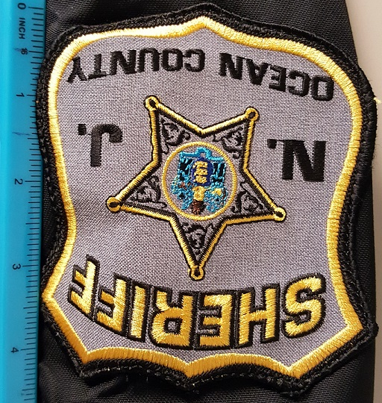 **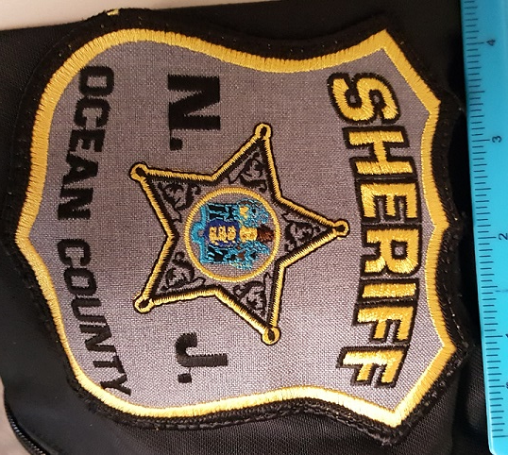**

**ITEM #226 - SHERIFF'S STAR BADGE PATCH**

Size: Approx. 2 ¾” H X 2 ¾” W

Threads: 11

Stitch Count: Approximately 6,124 on the embroidered parts, not including woven parts

Patch Colors: Silver or Gold

See Diagram Below

**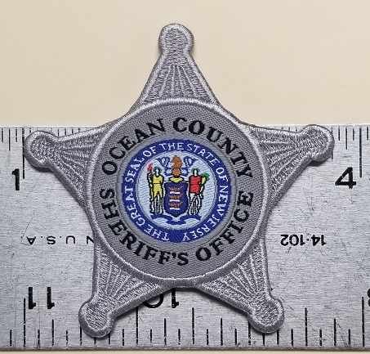 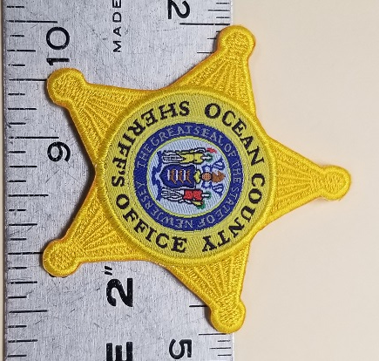**

**SECTION VI – UNIFORMS, EQUIPMENT & ACCESSORIES FOR THE SHERIFF'S OFFICE**

**(CONT’D)**

**ITEM #227 - OCEAN COUNTY POLICE ACADEMY PATCH**

Size: 3 3/8” diameter.

See Diagram Below

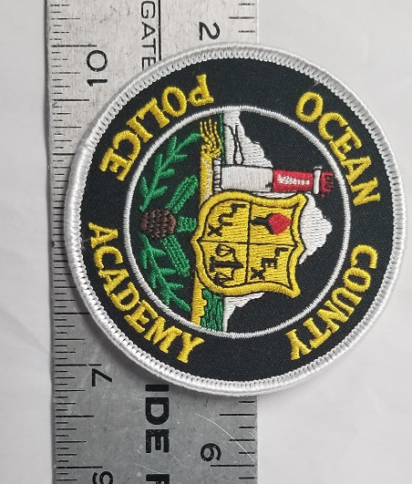

**SECTION VII – TACTICAL GEAR FOR THE SHERIFF’S OFFICE**

**ITEM #228 - NYLON DUTY OUTER BELT**

Manufacturer: BIANCHI PATROLTEK 8100 WEB DUTY BELT, or Equal

Color: Black

Features: 2” Double Nylon

Size: S-4X

**ITEM #229 - NYLON DUTY INNER BELT**

Manufacturer: BIANCHI 8105 PATROLTEK NYLON LINER BELT, or Equal

Color: Black

Features: 2” Double Nylon

Size: S-4X

**ITEM #230 - NYLON SILENT KEY HOLDER**

Manufacturer: BIANCHI ACCUMOLD #8016, or Equal

Color: Black

Features: Nylon, Hidden snap

**ITEM #231 - MOLLE BATTLE BELT**

Manufacturer: Safariland, **NO EXCEPTIONS**

Material: Nylon

Color: All colors

Design: Two rows of MOLLE loop webbing w/ UBL- universal belt loop. Anti-bacterial and

anti-microbial foam neoprene padding

Fastener: Shatter resistant buckle

Size: 30”- 46”

**ITEM #232 - GAS MASK POUCH**

Manufacturer: Safariland, **NO EXCEPTIONS**

Material: 1000 Denier Cordura

Color: All colors

Design: Lightweight Helium whisper backer w/ abrasion resistance

Fastener: MOLLE

**ITEM #233 - PADDED BELT SLOTTED**

Manufacturer: High speed gear, **NO EXCEPTIONS**

Material: Nylon .75” thick and 4.5” tall

Color: All colors

Design: Neoprene padding

Fastener: Velcro

Size: SM- XL

**ITEM #234 – COBRA 1.75” RIGGER BELT WITH D-RING**

Manufacturer: High speed gear, **NO EXCEPTIONS**

Material: 2 layers of nylon

Color: All colors

Design: 1.75” type 13 webbing sewn together with 5 rows of bonded 138 nylon thread.

Fastener: Quick release COBRA buckle

Size: SM- 3X

**SECTION VII – TACTICAL GEAR FOR THE SHERIFF’S OFFICE (CONT’D)**

**ITEM #235 – SINGLE PISTOL TACO LT MOLLE POUCH**

Manufacturer: High speed gear, **NO EXCEPTIONS**

Material: Nylon

Color: All colors

Design: Single pistol magazine pouch

Fastener: MOLLE attachment w/ HSGI clips for attachment to PALS.

**ITEM #236 - DOUBLE PISTOL TACO LT MOLLE POUCH**

Manufacturer: High speed gear, **NO EXCEPTIONS**

Material: Nylon

Color: All colors

Design: Double pistol magazine pouch

Fastener: MOLLE attachment w/ HSGI clips for attachment to PALS.

**ITEM #237 - DOUBLE DECKER LT TACO MOLLE POUCH**

Manufacturer: High speed gear, **NO EXCEPTIONS**

Material: Nylon

Color: All colors

Design: Single rifle plus single pistol magazine combined pouch

Fastener: MOLLE attachment w/ HSGI clips for attachment to PALS.

**ITEM #238 - MULTI-ACCESS COMM TACO MOLLE POUCH**

Manufacturer: High speed gear, **NO EXCEPTIONS**

Material: Nylon

Color: All colors

Design: 2.5” side openings w/ open top design to fit Motorola APX6000 Li radio

Fastener: MOLLE attachment w/ HSGI clips for attachment to PALS.

**ITEM #239 - DUTY EXTENDED PISTOL TACO MOLLE POUCH**

Manufacturer: High speed gear, **NO EXCEPTIONS**

Material: 1000D Cordura

Color: All colors

Design: Extended pouch for expandable batons, flashlights or other equipment.

Fastener: MOLLE attachment w/ HSGI clips for attachment to PALS.

**ITEM #240 - KYDEX DUTY HANDCUFF TACO MOLLE POUCH**

Manufacturer: High speed gear, **NO EXCEPTIONS**

Material: Nylon/ Kydex

Color: All colors

Design: Fits standard or hinged handcuffs

Fastener: MOLLE attachment w/ HSGI clips for attachment to PALS.

**ITEM #241 - HANDCUFF TACO COVERED MOLLE POUCH**

Manufacturer: High speed gear, **NO EXCEPTIONS**

Material: Nylon/ Kydex

Color: All colors

Design: Fits standard or hinged handcuffs

**SECTION VII – TACTICAL GEAR FOR THE SHERIFF’S OFFICE** **(CONT’D)**

**ITEM #242 - SHOT SHELL MOLLE POUCH**

Manufacturer: High speed gear, **NO EXCEPTIONS**

Material: 1000D Cordura

Color: All colors

Design: Shot shell pouch holding 12 shots shells internally with woven elastic.

Fastener: MOLLE attachment w/ HSGI clips for attachment to PALS

**ITEM #243 - DUTY DOUBLE SMOKE GENADE TACO MOLLE POUCH**

Manufacturer: High speed gear, **NO EXCEPTIONS**

Material: 1000D Cordura

Color: All colors

Design: Designed to carry two 40/ 37 mm grenades.

Fastener: MOLLE attachment w/ HSGI clips for attachment to PALS

**ITEM #244 - TOURNIQUET TACO MOLLE POUCH**

Manufacturer: High speed gear, **NO EXCEPTIONS**

Material: 1000D and 500D Cordura nylon

Color: All colors

Design: Fits various tourniquets

Fastener: MOLLE attachment w/ HSGI clips for attachment to PALS.

**ITEM #245 - STUN GUN TACO MOLLE POUCH**

Manufacturer: High speed gear, **NO EXCEPTIONS**

Material: Nylon

Color: All colors

Design: Rigid webbing sides to fit X2 Taser

Fastener: MOLLE attachment w/ HSGI clips for attachment to PALS.

**ITEM #246 - MAG-NET DUMP V2 TACO MOLLE POUCH**

Manufacturer: High speed gear, **NO EXCEPTIONS**

Material: 1000D Cordura

Color: All colors

Design: Mesh design pouch

Fastener: Hook and loop wrap

**ITEM #247 - SINGLE PISTOL LT TACO BELT POUCH**

Manufacturer: High speed gear, **NO EXCEPTIONS**

Material: Nylon

Color: All colors

Design: Single pistol magazine pouch

Fastener: Velcro attachment for up to 2” belt.

**ITEM #248 - DOUBLE PISTOL LT TACO BELT POUCH**

Manufacturer: High speed gear, **NO EXCEPTIONS**

Material: Nylon

Color: All colors

Design: Double pistol magazine pouch

Fastener: Velcro attachment for up to 2” belt.

**SECTION VII – TACTICAL GEAR FOR THE SHERIFF’S OFFICE (CONT’D)**

**ITEM #249 - DOUBLE DECKER LT TACO BELT POUCH**

Manufacturer: High speed gear, **NO EXCEPTIONS**

Material: Nylon

Color: All colors

Design: Single rifle plus single pistol magazine combined pouch

Fastener: Velcro attachment for up to 2” belt.

**ITEM #250 - KYDEX HANDCUFF TACO BELT POUCH**

Manufacturer: High speed gear, **NO EXCEPTIONS**

Material: Nylon/ Kydex

Color: All colors

Design: Fits standard or hinged handcuffs

Fastener: 2” Wide elastic loops w/ HSGI clips

**ITEM #251 - EXTENDED PISTOL TACO BELT POUCH**

Manufacturer: High speed gear, **NO EXCEPTIONS**

Material: 1000D Cordura

Color: All colors

Design: Extended pouch for expandable batons, flashlights or other equipment.

Fastener: 2” Wide elastic loops w/ HSGI clips

**ITEM #252 - KYDEX TOURNIQUET TACO BELT POUCH**

Manufacturer: High speed gear, **NO EXCEPTIONS**

Material: 1000D and 500D Cordura nylon

Color: All colors

Design: Fits various tourniquets

Fastener: 2” Wide elastic loops w/ HSGI clips

**ITEM #253 - SNIPER WAIST PACK BELT POUCH**

Manufacturer: High speed gear, **NO EXCEPTIONS**

Material: 1000D Cordura

Color: All colors

Design: 4 pouches secured directly to belt.

Fastener: 2” Wide elastic loops w/ HSGI clips

**ITEM #254 - MAXPEDITION IRONSTORM ADVENTURE AGR BAG**

Manufacturer: Maxpedition, **NO EXCEPTIONS**

Material: 1000 Denier water and abrasion resistant light-weight ballistic nylon fabric.

500 Denier Hex Ripstop water and abrasion resistant light-weight ballistic nylon fabric.

Color: Black

Design: Triple polyurethane coated for water resistance, high tensile strength composite nylon, #AS-100 high grade closed-cell foam padding, internal seams taped and finished, stress points double stitched, bartacked, circular bartacked X stitching, Teflon fabric protector

Fastener: YKK high strength zippers, UTX Duraflex nylon buckles

**SECTION VIII – TAILORING AND ALTERATIONS, AS NEEDED**

**ITEM #255 - TAILORING PANTS TAPER**

Pant leg tailoring for hem & taper

**ITEM #256 - TAILORING SHIRT TAPER**

Shirt tailoring for arm length & taper.

**ITEM #257 - TAILORING SHIRT ZIPPER**

Shirt tailoring for adding/ removing zipper.

**ITEM #258 - TAILORING SHIRT OR JACKET BADGE PATCH**

Shirt and or jacket tailoring to add badge patch.

**ITEM #259 - TAILORING SHIRT OR JACKET NAMESTRIP ADDED**

Shirt or jacket tailoring to add name strip.

**ITEM #260 - TAILORING SHIRT OR JACKET CPL. SGT. CHEVRONS ON SLEEVE**

Shirt or jacket tailoring to add Cpl. or Sgt. Chevrons on sleeves.

**ITEM #261 - TAILORING SHIRT OR JACKET HASH MARKS**

Shirt or jacket tailoring to add Hash marks on sleeves.

**ITEM #262 - TAILORING SHIRT OR JACKET RANK INSIGNIA COLLAR**

Shirt or jacket tailoring to add rank insignia embroidered on collars.

**ITEM #263 - TAILORING SHIRT OR JACKET RANK INSIGNIA EPILATES**

Shirt or jacket tailoring to add rank insignia embroidered on epilates.

**ITEM #264 – REMOVAL OF PATCHES**

Tailoring to have patches removed from shirt or jackets.

**ITEM #265 - TAILORING FOR PERSHING STYLE HAT**

Tailoring to include plain leather overhead strap w/ gold buckle, front strap w/ gold lace & two (2) gold NJ state buttons.

**SECTION IX - DISCOUNT RATE FOR ITEMS NOT LISTED HEREIN**

**ITEM #266 - PERCENTAGE OF DISCOUNT OFF CATALOG PRICE**

The County expects there may be a need for new Uniform Items that are similar in nature but not already included in these specifications. For these unlisted items, the vendor shall offer a discount off of the   
catalog price. This percentage discount shall also be applied to all embroider/imprinting needs, as well as patches, insignias, and name strips and shall be extended to all sizes (regular, short and long) and colors available on the manufacturer of the requested item. Tie bars and nameplates shall also fall under this Section.

This section shall be awarded to the vendor(s) awarded any of the other eight (8) sections. The County   
reserves the right to award multiple contracts for this section only.

The department shall request quotes from various awarded vendors to determine the lowest price before   
placing their order.

**DIAGRAMS FOR EMBROIDERY AND LETTERING FOR SHERIFF’S DEPARTMENT**

**DIAGRAM #4**

“SHERIFF” Gold lettering, **BOLD** font.

**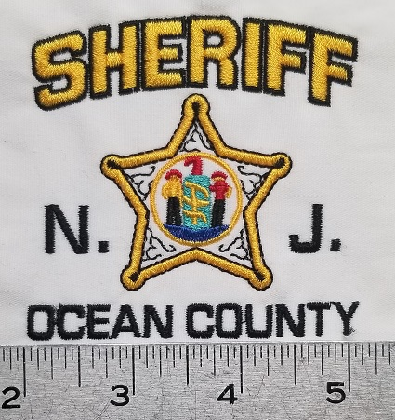**

**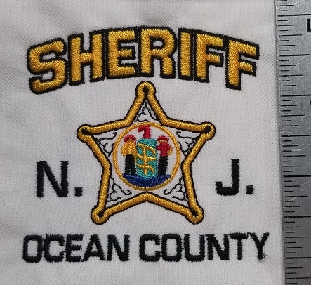**

**DIAGRAMS FOR EMBROIDERY AND LETTERING FOR SHERIFF’S DEPARTMENT (CONT’D)**

**DIAGRAM #5**

“SHERIFF” Grey lettering, **BOLD** font for GREY SHIRT.

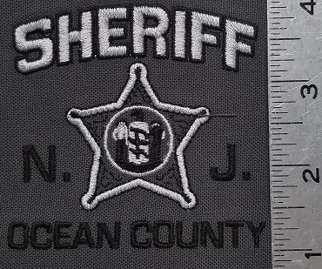

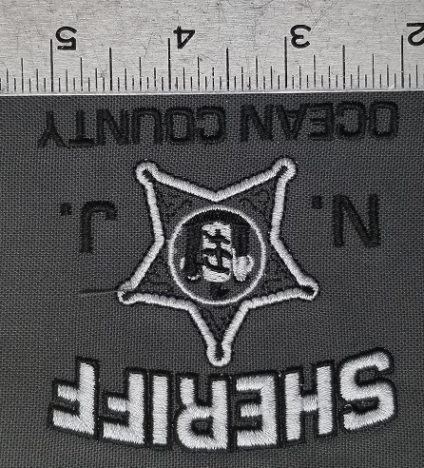

**DIAGRAMS FOR EMBROIDERY AND LETTERING FOR SHERIFF’S DEPARTMENT (CONT’D)**

**DIAGRAM #6**

“SHERIFF” Black lettering, not bold font for GREY SHIRT.

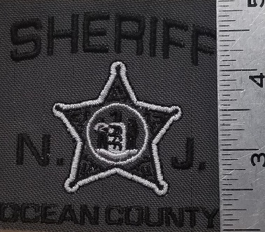

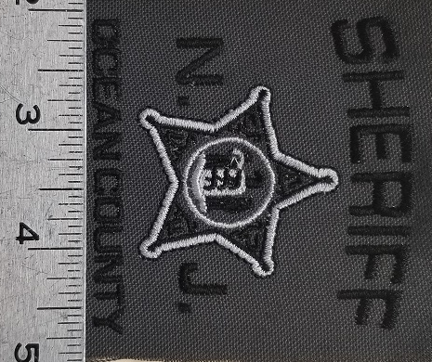

**DIAGRAMS FOR EMBROIDERY AND LETTERING FOR SHERIFF’S DEPARTMENT (CONT’D)**

**DIAGRAM #7**

“SHERIFF” Grey lettering, **BOLD** font for BLACK SHIRT.

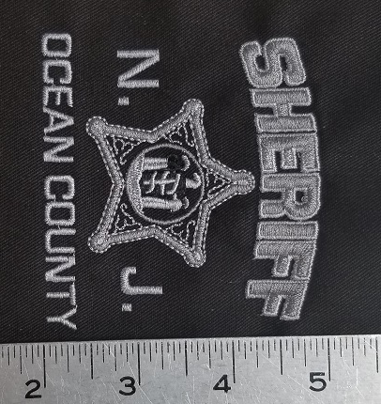

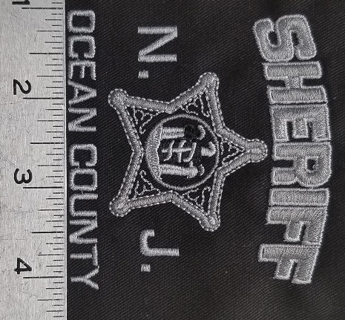

**DIAGRAMS FOR EMBROIDERY AND LETTERING FOR SHERIFF’S DEPARTMENT (CONT’D)**

**DIAGRAM #8**

“SHERIFF” Grey lettering, not bold font for BLACK SHIRT.

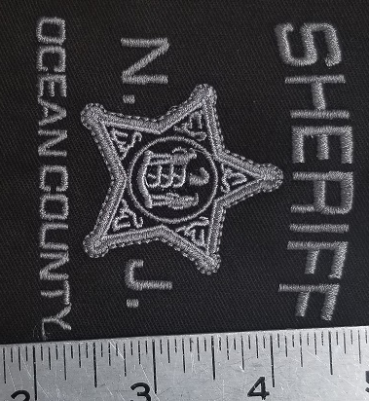

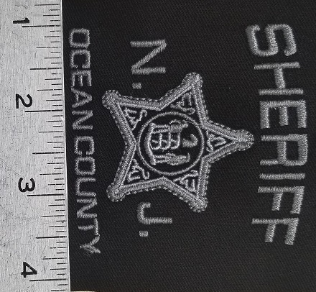

**DIAGRAMS FOR EMBROIDERY AND LETTERING FOR SHERIFF’S DEPARTMENT (CONT’D)**

**DIAGRAM #9a**

“SHERIFF” Silver reflective lettering for long sleeve shirt.

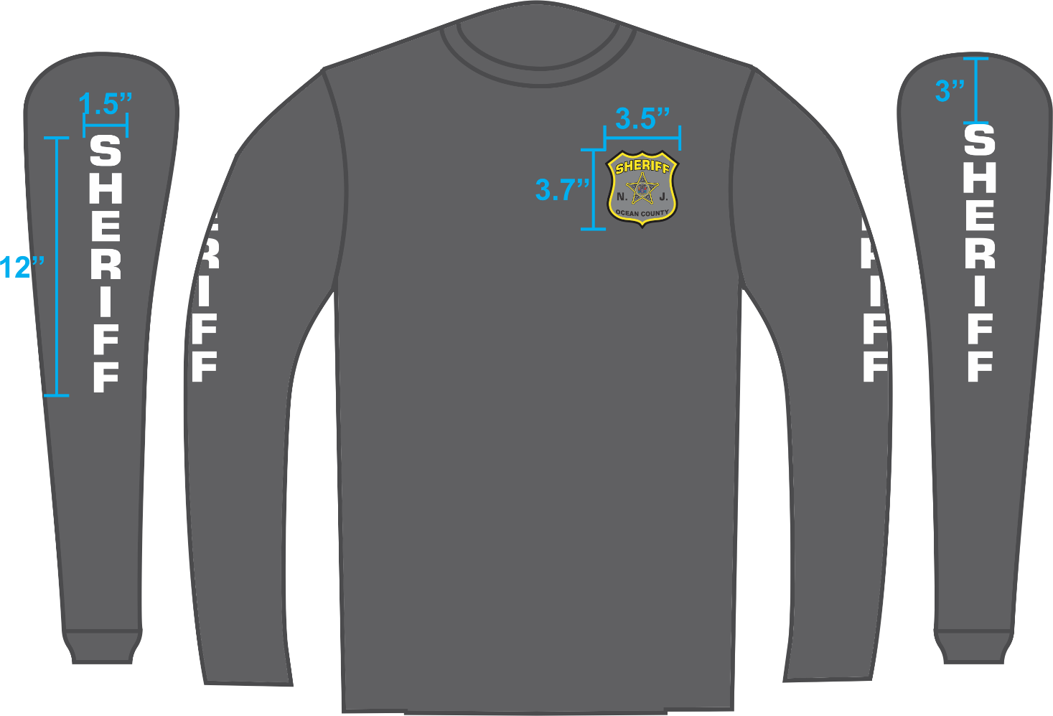

**DIAGRAM #9b**

“SHERIFF” Silver reflective lettering for short sleeve shirt.

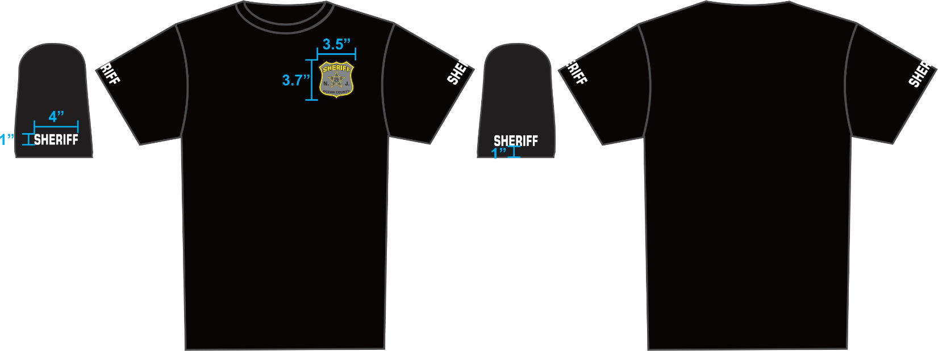

**DIAGRAMS FOR EMBROIDERY AND LETTERING FOR SHERIFF’S DEPARTMENT (CONT’D)**

**DIAGRAM #10**

“STAFF” khaki thread **BOLD** lettering.

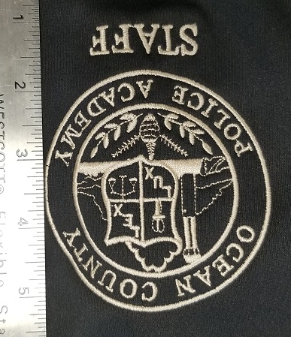

**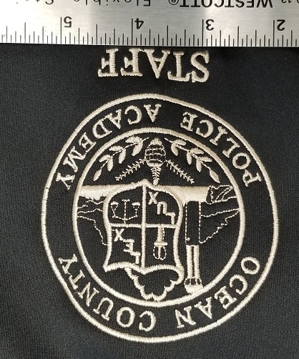**

**DIAGRAMS FOR EMBROIDERY AND LETTERING FOR SHERIFF’S DEPARTMENT (CONT’D)**

**DIAGRAM #11**

“INSTRUCTOR” gold thread **BOLD** lettering.

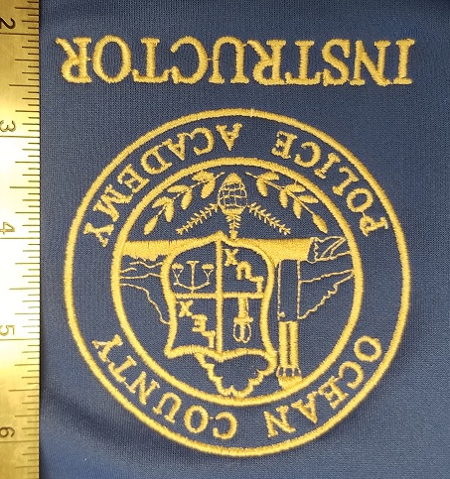

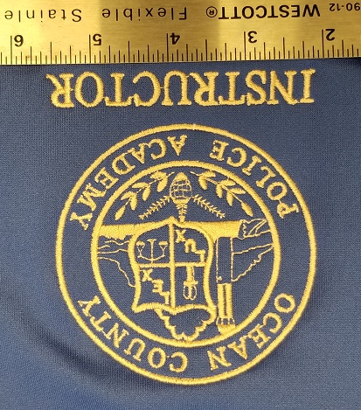

**DIAGRAMS FOR EMBROIDERY AND LETTERING FOR SHERIFF’S DEPARTMENT (CONT’D)**

**DIAGRAM #12**

“INSTRUCTOR” and logo in yellow w/ **BOLD** lettering.

*Used for PT INSTRUCTORS*

**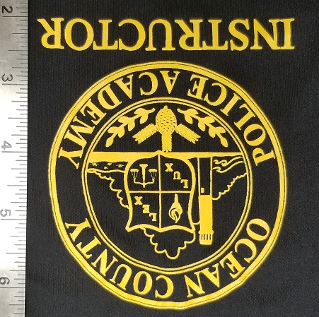**

**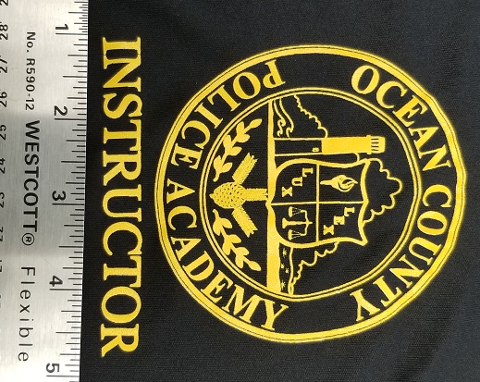**

**DIAGRAMS FOR EMBROIDERY AND LETTERING FOR SHERIFF’S DEPARTMENT (CONT’D)**

**DIAGRAM #13**

“INSTRUCTOR” and logo in black w/ **BOLD** lettering.

*Used for FIREARMS INSTRUCTORS*

**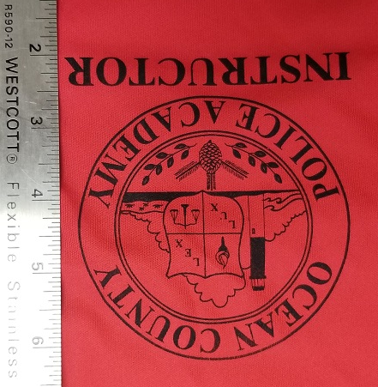**

**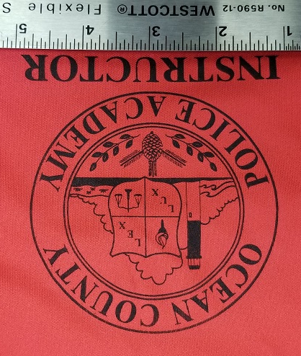**

**DIAGRAMS FOR EMBROIDERY AND LETTERING FOR SHERIFF’S DEPARTMENT (CONT’D)**

**DIAGRAM #14**

*This silk screened logo is for PT Gear*

**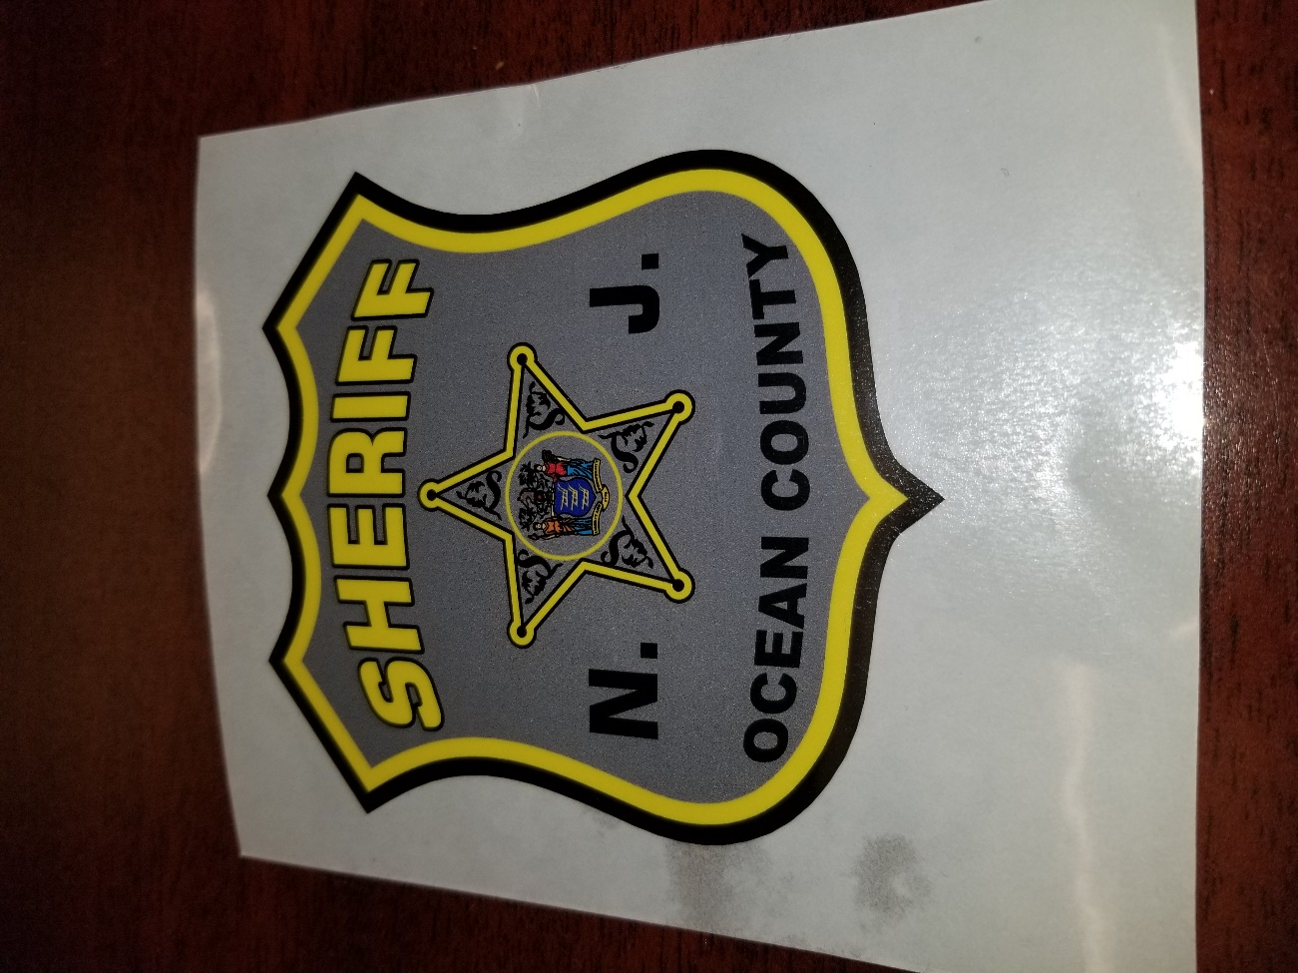**

**DIAGRAMS FOR EMBROIDERY AND LETTERING FOR SHERIFF’S DEPARTMENT (CONT’D)**

**DIAGRAM #15**

*Used for Rank Insignias.*

**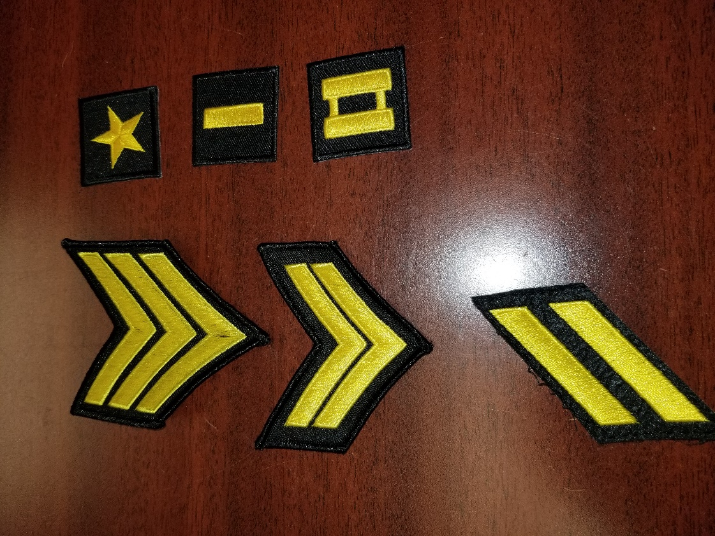**

**CHART OF VARIOUS LOGOS FOR OCEAN COUNTY SHERIFF’S OFFICE**

|  |  |  |  |  |  |
| --- | --- | --- | --- | --- | --- |
| **LOGO** | **DIAGRAM #** | **THREAD COUNT** | **SIZES** | **COLORS** | **IMAGE** |
| OCEAN COUNTY SHERIFF | **16** | 10677 | 2.61W X 2.50H | 1801 WHT, 1839 RED, 1758 BRN,  1766 PUR, 1800 BLK, 1971 DYEL | **C:\Users\krice\AppData\Local\Microsoft\Windows\INetCache\Content.Outlook\KNJA916D\Diagram4- Sheriff on Black_.jpg** |
| OCEAN COUNTY SHERIFF C.E.R.T. | **17** | 11211 | 2.61W X 2.84H | 1801 WHT, 1839 RED, 1758 BRN,  1766 PUR, 1800 BLK, 1971 DYEL | C:\Users\krice\AppData\Local\Microsoft\Windows\INetCache\Content.Outlook\KNJA916D\Diagram 17 - OC CERT.jpg |
| OCEAN COUNTY SHERIFF COMMUNICATIONS | **18** | 12288 | 2.96W X 2.85H | 1802 WHT, 1839 RED, 1758 BRN,  1766 PUR, 1800 BLK, 1971 DYEL | C:\Users\krice\Documents\KARENS DESKTOP FOLDER\Diagram 18 - OC Communications.jpg |
| OCEAN COUNTY SHERIFF EMERGENCY MANAGEMENT | **19** | 12668 | 3.57W X 2.82H | 1803 WHT, 1839 RED, 1758 BRN,  1766 PUR, 1800 BLK, 1971 DYEL | C:\Users\krice\AppData\Local\Microsoft\Windows\INetCache\Content.Word\Diagram 19 - OC OEM.jpg |
| OCEAN COUNTY SHERIFF HAT LOGO | **20** | 10677 | 2.61W X 2.50H | 1804 WHT, 1839 RED, 1758 BRN,  1766 PUR, 1800 BLK, 1971 DYEL | C:\Users\krice\AppData\Local\Microsoft\Windows\INetCache\Content.Outlook\KNJA916D\Diagram 20 - OC Hat Logo.jpg |
| OCEAN COUNTY FIRE MARSHAL | **21** | 15159 | 3.51W X 3.78H | 1821 RUST, 1971 DYEL,  1800 BLK |  |
| OCEAN COUNTY POLICE ACADEMY | **22** | 9109 | 3.03W X 3.03H | 1801 WHT |  |